**Zach Adair – MSDS 610 Week 4 Lab Write up**

**Using Hive on your Vagrant/OpenStack Cluster**

**Regis University – College of Computer & Information Sciences**

**Data Science – Data Engineering**

**February 5, 2019**

# **Lab Overview**

* Resume your Vagrant VMs to work with the cluster using Cmder.
* Use the ambari console to view the status of the cluster and Hive
* Open your Hive 2 to enter various Hiver QL commands to create tables, load data, and query the data
* When you are done working with Hive, suspend your cluster and exit from Cmder.

If you have not watched this video, then it is essential that you watch this tutorial (click link below) about Hive prior to beginning this lab. This is the same link found in the Worldclass Week 4 – Lab 4 section. Keep in mind that files shown at the end of the video (regarding baseball) are different from the files we will use in this lab. The baseball files are only used as examples in the video to help you understand the concepts.

[**https://hortonworks.com/video/hadoop-tutorial-apache-hive-2/**](https://hortonworks.com/video/hadoop-tutorial-apache-hive-2/)

# **Part 1**

## Resume VMs

Start Cmder, if it is not running. Change directories to the centos 7.4_8 directory created in lab 2.

**NOTE:** If you are a Cloud (OpenStack) beta tester you will bring up your cluster by first logging into the Regis VPN, and then logging into OpenStack to resume your instances. <http://192.168.200.19/dashboard/>

This can take a few minutes to restart all of the VMs (c7401 and c7402). Eventually you will see that all of the **VMs have restarted as shown below.**

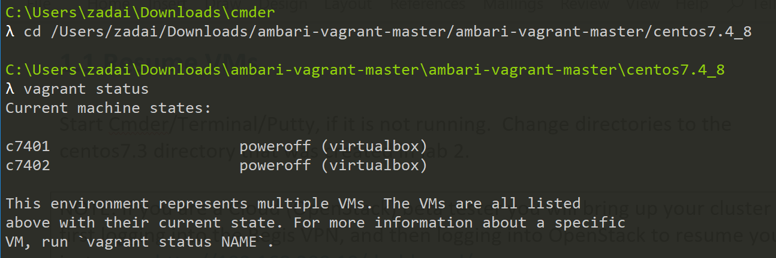

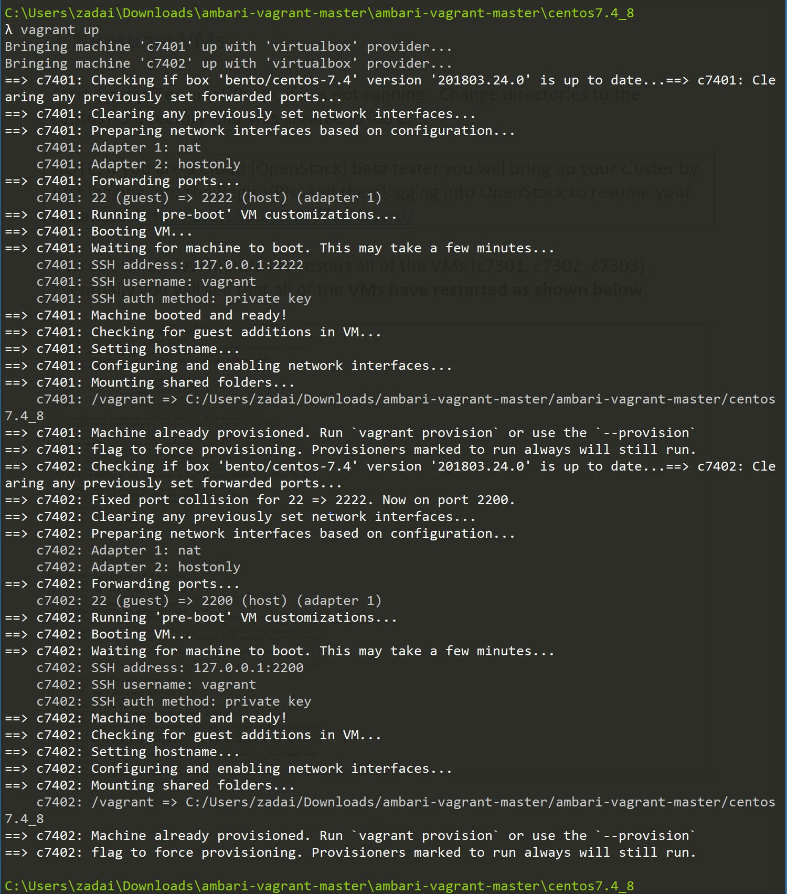

## Ambari Console

Now that the VMs are restarted (booted) and running again, open up a Browser window to check on the status of the VMs using ambari.

**NOTE:** If you are a Cloud (OpenStack) beta tester you will log into Ambari using **localhost:8080** for your URL. Remember to start Port Forwarding prior to logging into Ambari. Refer back to lab 2 if needed.

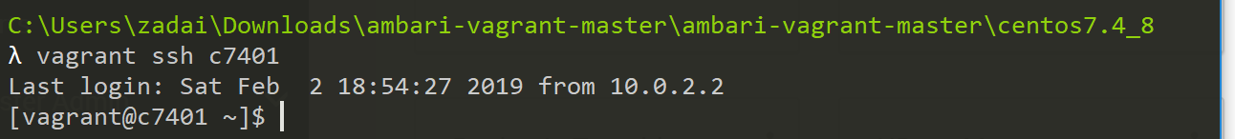

**In the Google Chrome Browser (or other browser) address box, enter**

C7401.ambari.apache.org:8080

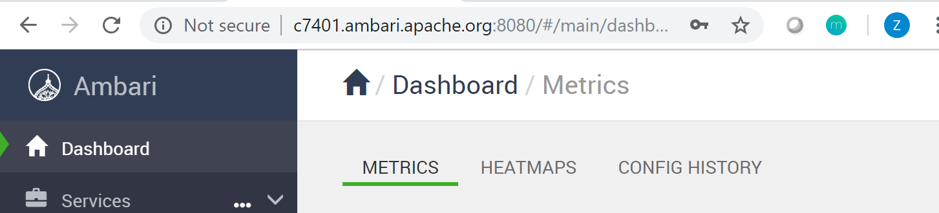

**As you recall, this IP address was set with the ‘append-to-etc-hosts.txt’ file earlier.**

**For the ID and password enter admin. Click on the sign in button**

Username: admin

Password: admin

**Once logged in, your window should look similar to the following. Notice that we have three datanodes that are live (running), provided that you created 3 VMs in the last lab. If you only created 2 data nodes, you will see 2 datanodes running.**

**My data nodes were not running properly so I am going to have to revert back to lab 2 and do a manual start all to all of the hosts in the ambari environment.**

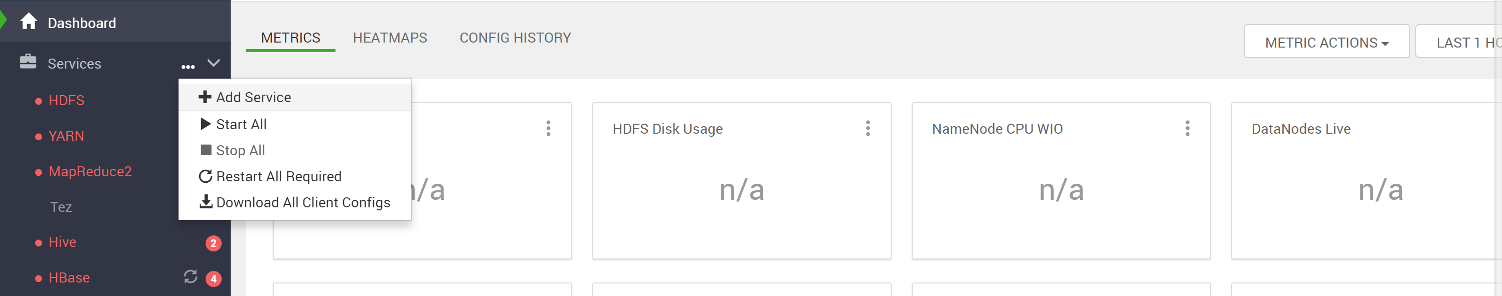

If some services still did not start, you may need to start them manually, I tend to click on Hosts, and then start the services on each hosts manually until everything is up and running successfully.

**After running the start all service I had some hosts that were still down. I went into hosts ran them manually and got them up and operating to look like the screen shot you see below. Meaning I can move onto section 1.3 of the Lab.**

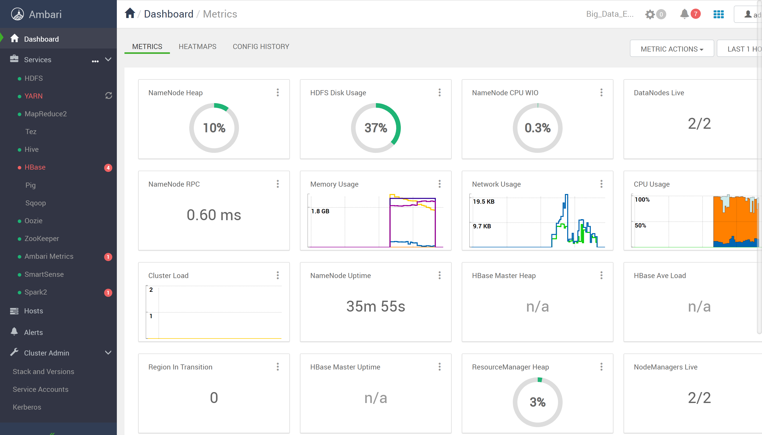

## Creating an hdfs user and group

The ambari admin user does not have permissions to create directories in the HDFS file system, but the Linux hdfs user does. We are going to create an Ambari hdfs user and group that will be able to create directories and change permissions.

Under the Admin menu, click **Manage Amabri:**

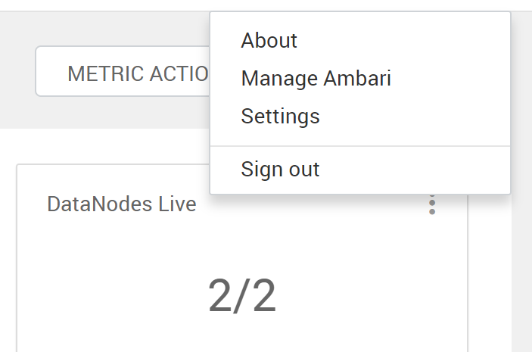

**Click on the Users link on the left sidebar.**

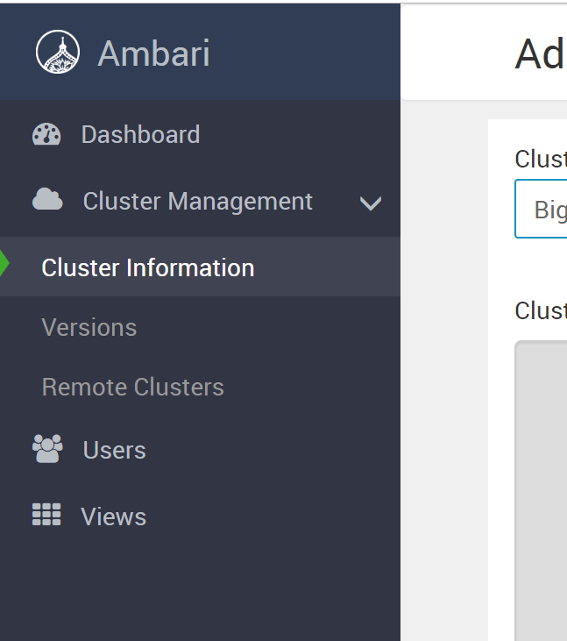

**Click on the Groups button to go to the Groups list.**

Click the Add Groups button.

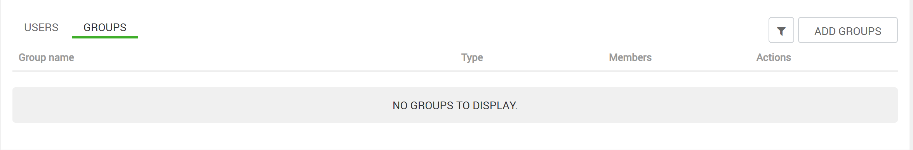

Enter hdfs as the group name and select Cluster Administrator in the Group Access drop down.

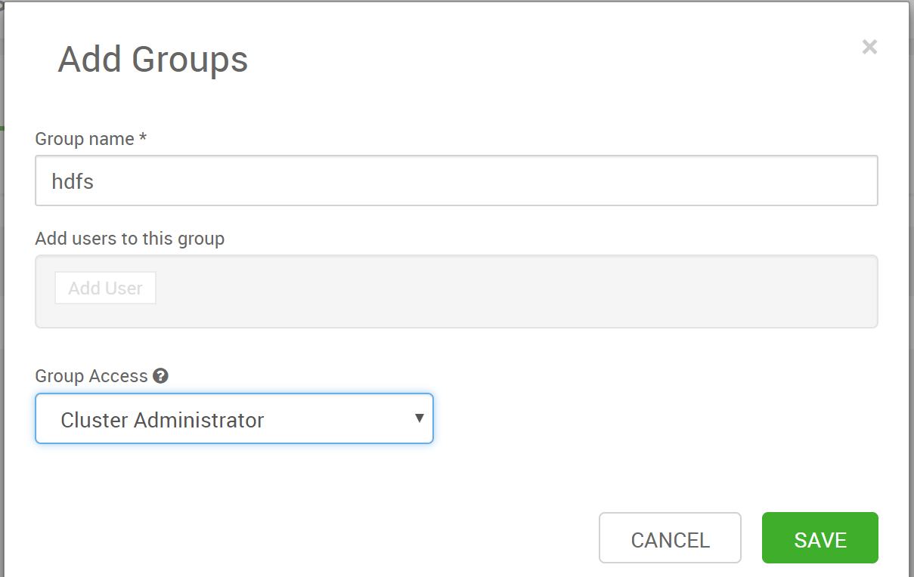

The group will now appear in the list of groups.

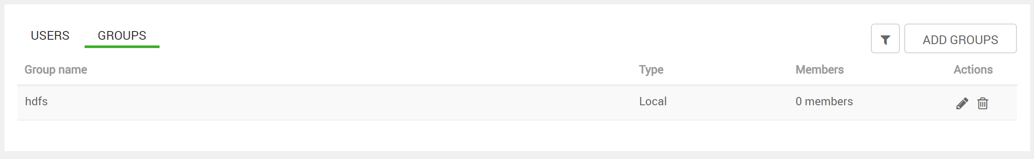

Now create the hdfs user. Click Users on the top left and then Add Users on the top right.

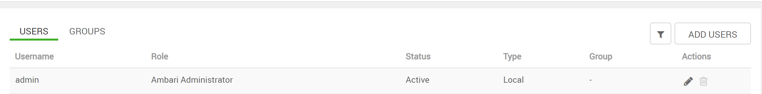

Make the username hdfs, choose a simple, easy to remember password (like “hdfs” – of course you wouldn’t do this in the real world!), make the user a Cluster Administrator and an Ambari Admin, then Save.

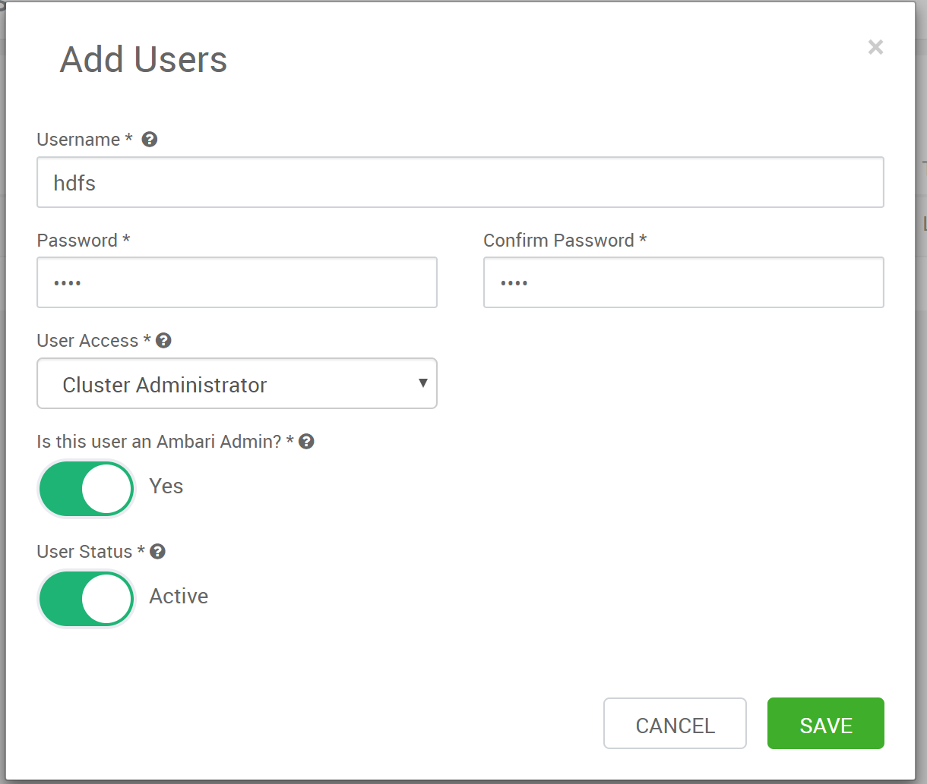

Next, click the “pencil” icon on the right side of the hdfs user to edit that account.

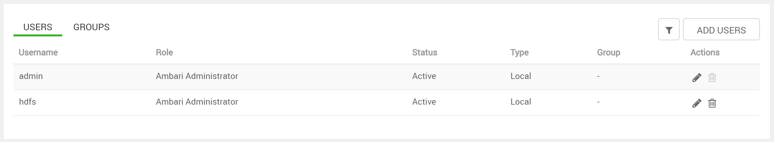

Type hdfs in the Local Group Membership box and hit enter. Click the green check mark.

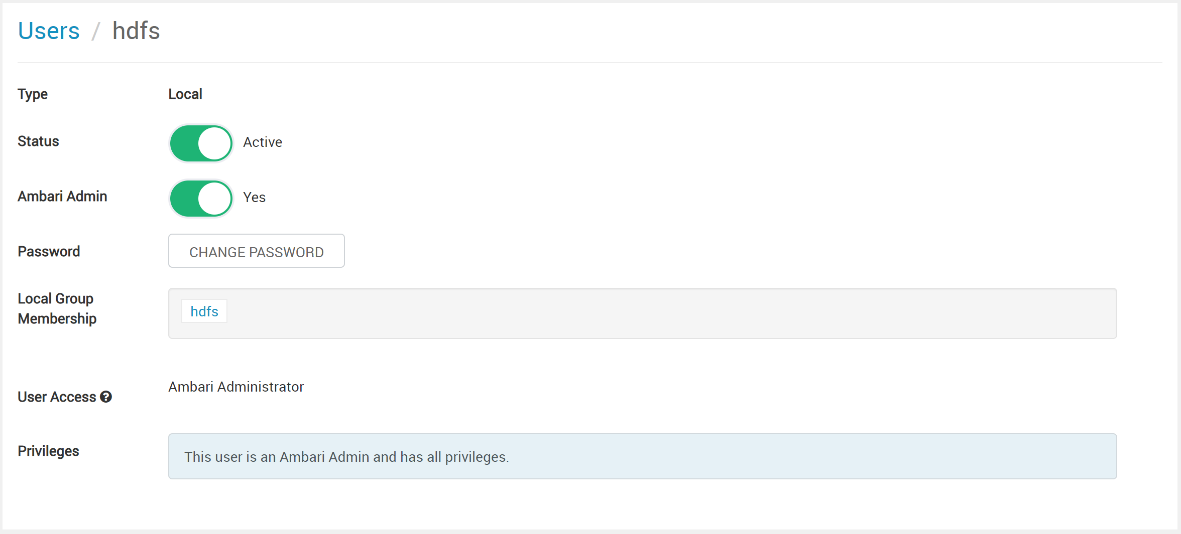

Click the Users link (in blue at the top, left) to get back to the users list.

**Adding the Data dictionary to HDFS**

We added the hdfs user so that we could use the Ambari GUI tool called Files View to add a directory and upload files, which is an alternate to the command line process we used in lab 2. To add the directory we will have to log out of the Admin user and log in to the hdfs user.

Log out by clicking on the admin button and select Sign Out.

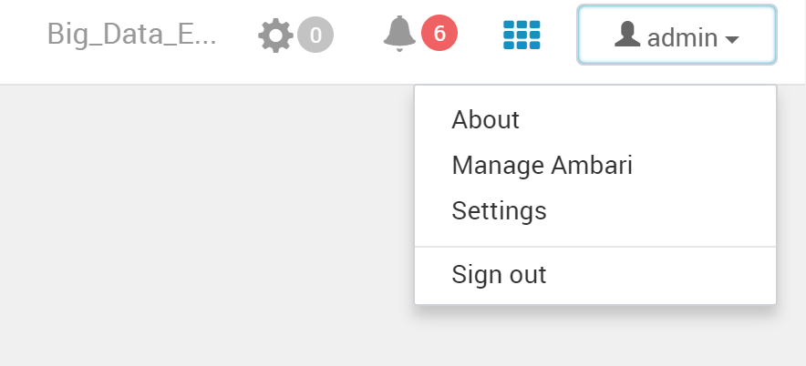

Login using the new hdfs user ID and password chosen earlier.

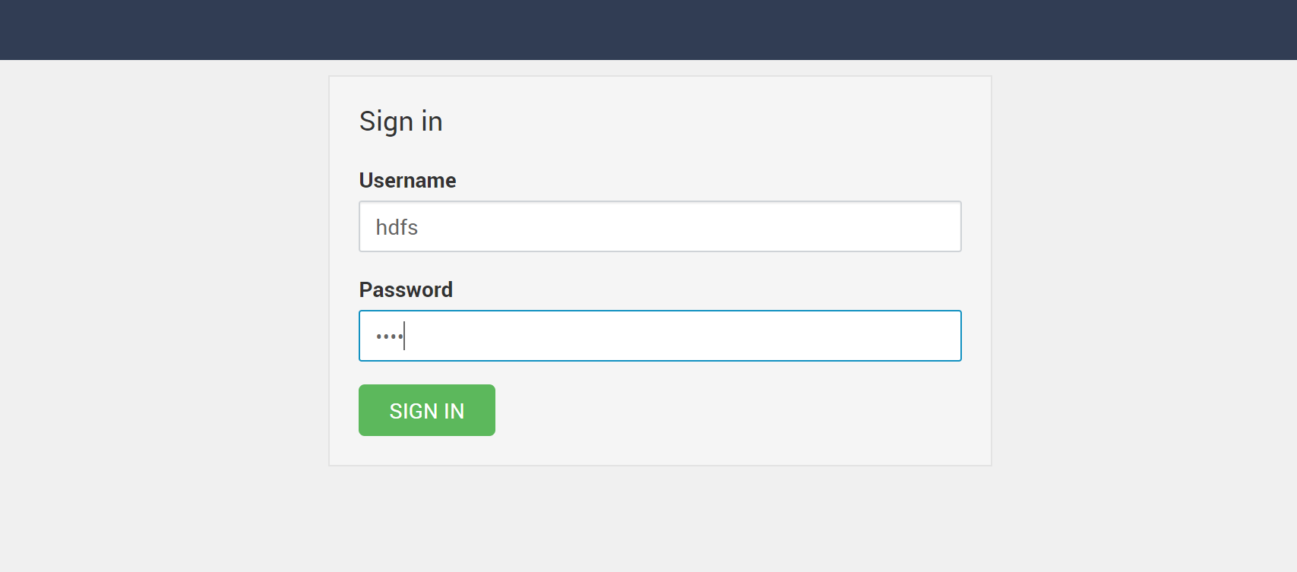

You’ll now see that your username is hdfs in the top right corner.

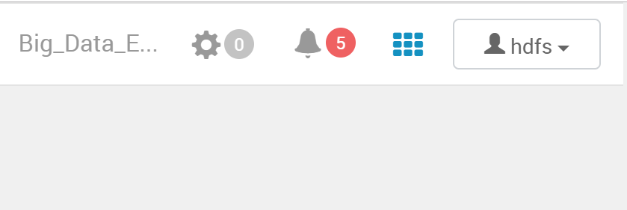

Click on the “Checkerboard” icon that is next to the hdfs button and the select the Files View menu option.

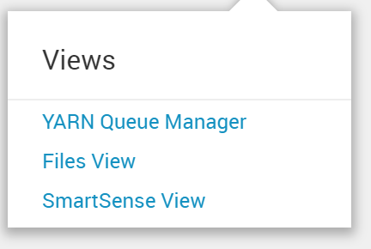

The Files View page will open and will look similar to below.

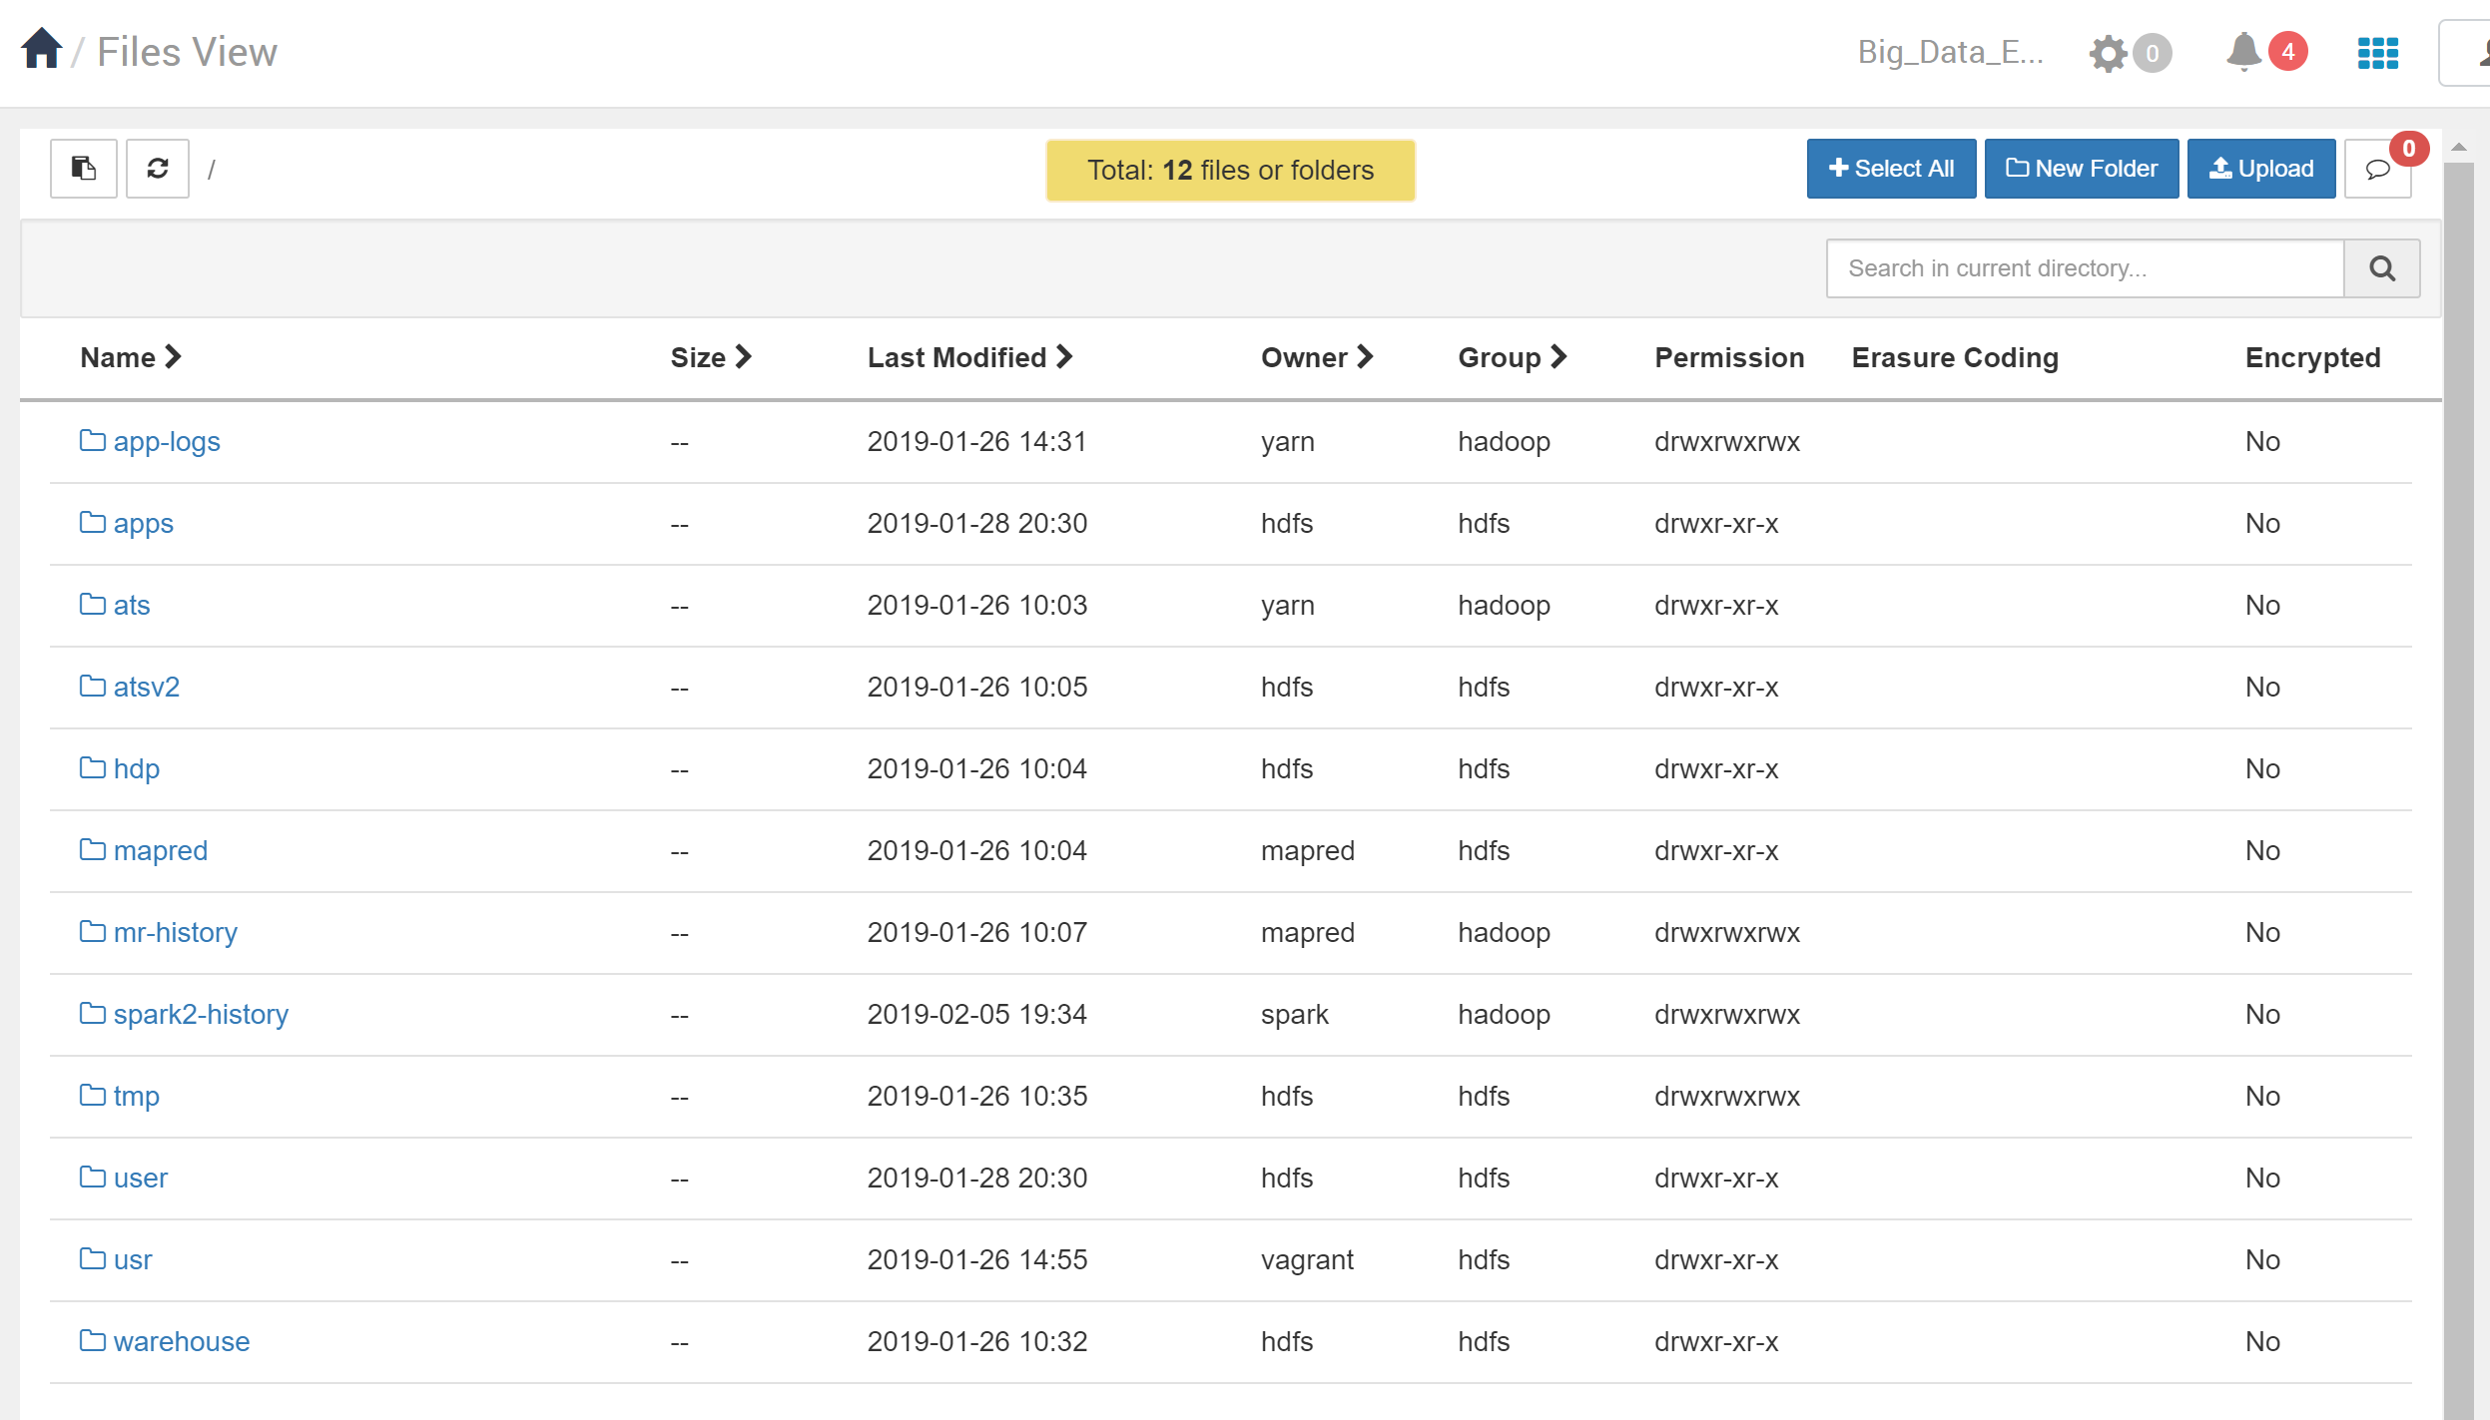

Click on the User Folder line (**don’t click the link, just click the line**) so that it is highlighted in blue as shown below.

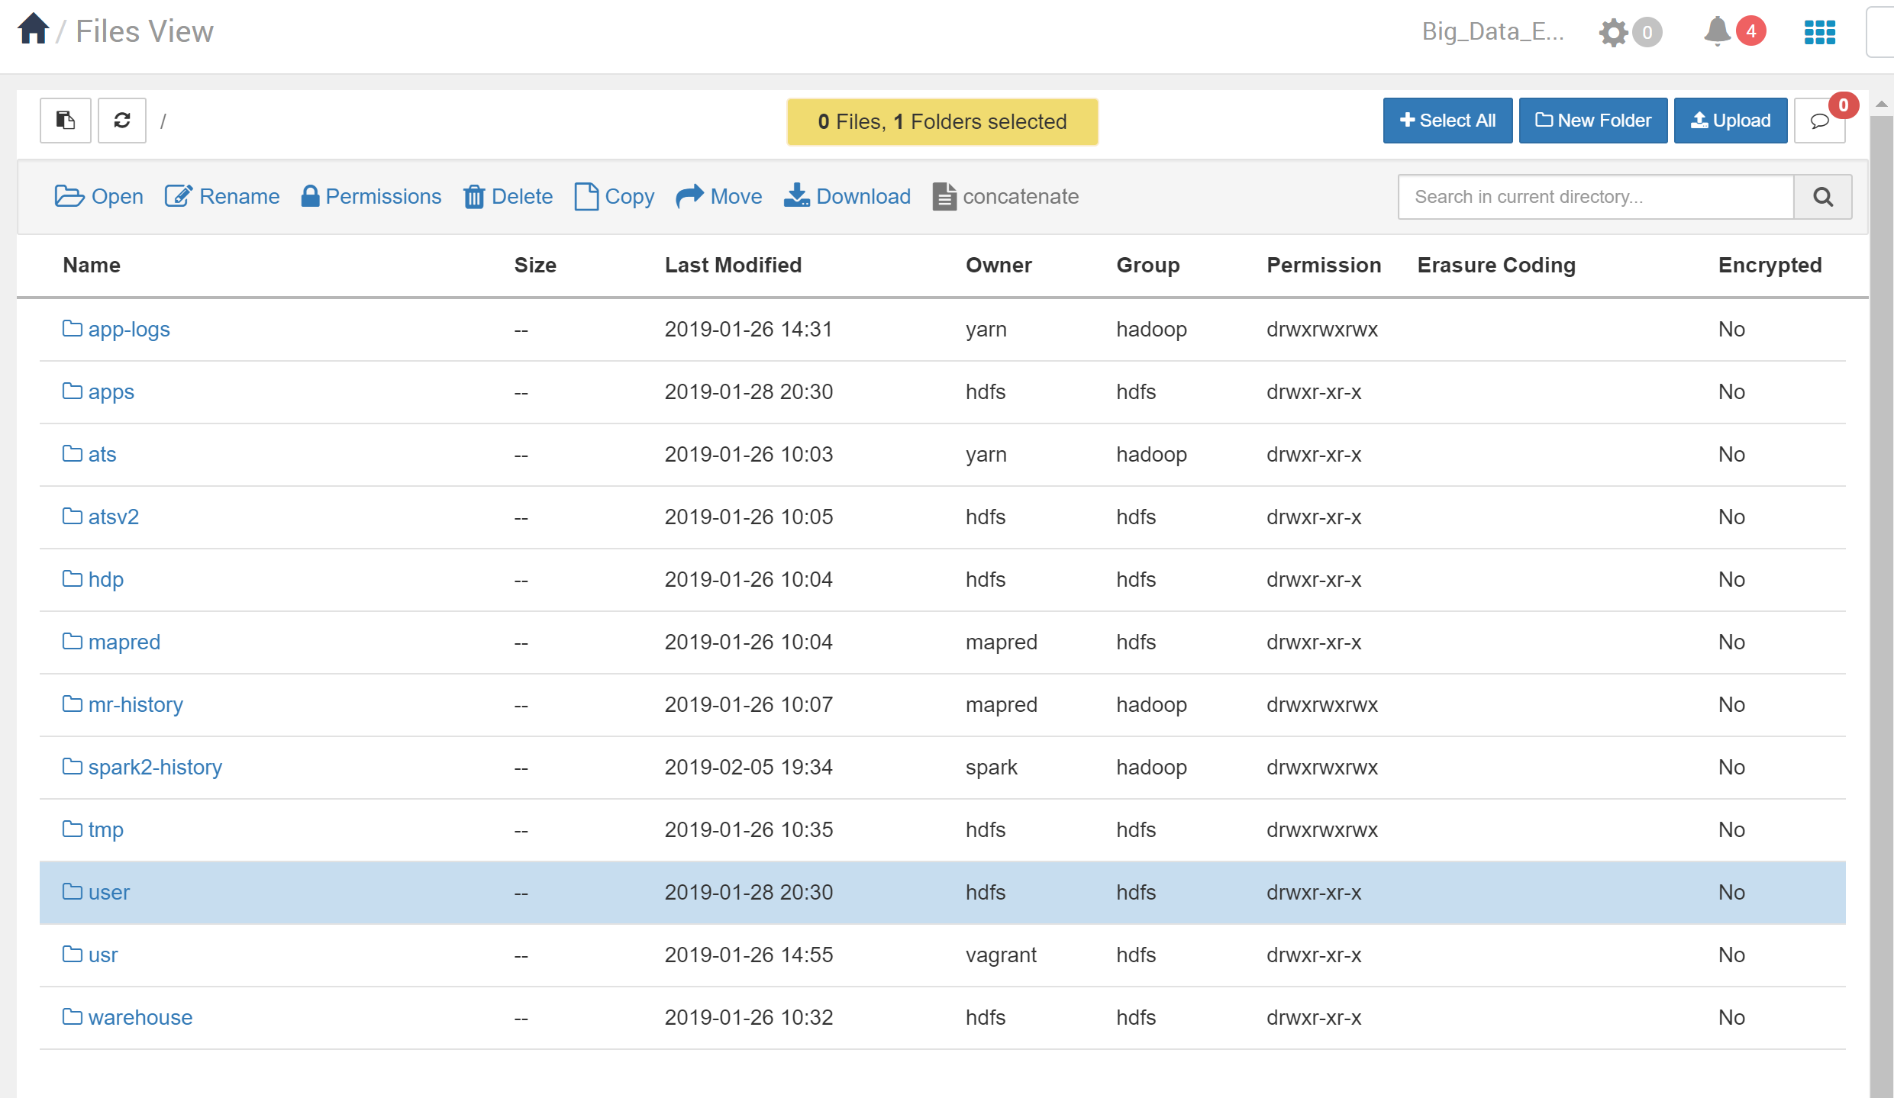

Then click on the permissions tab near the top of the window to open up a webpage for the folder permissions for the user folder. Change the permissions to add write for the user, group or other. Then, click the Save button

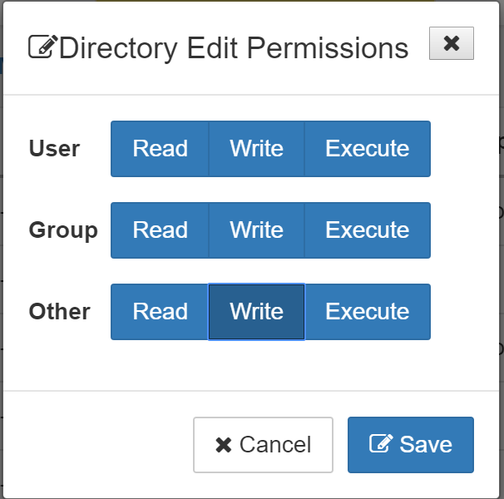

Now, click on the user directory link.

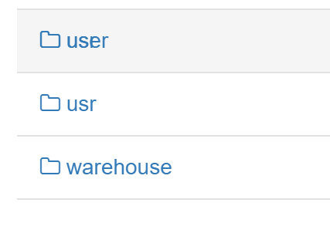

You will see a list of folders in the user folder. Click on the New folder button.

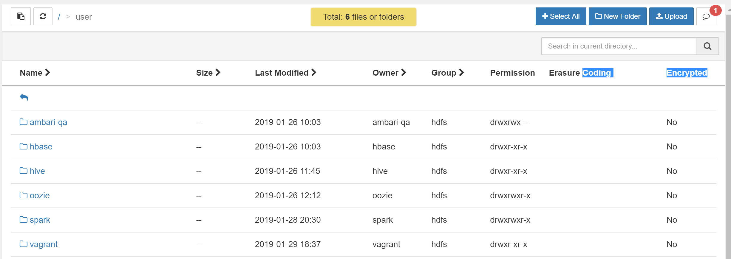

Create a new folder called admin as shown below. Click on the Add button to add the folder.



**The newly created admin file**

Set the permission on the directory to Read, Write, Execute for everyone. **(remember to click on the “line” of the admin user and not the actual link,** this will give you the Permissions option)

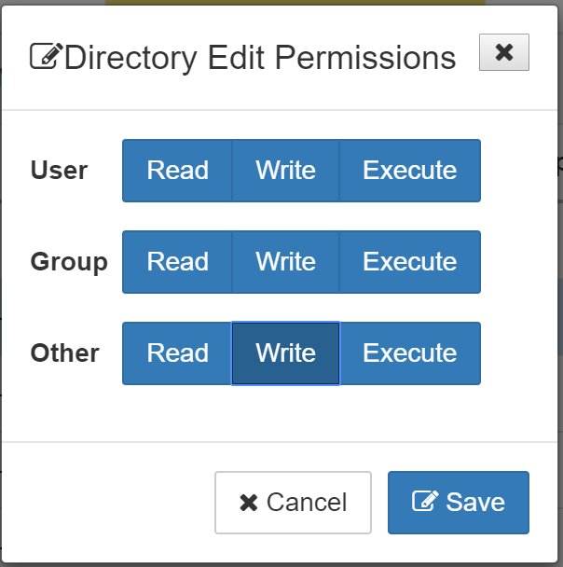

Now, to make sure we can access files from everywhere, we need to make a slight change to HDFS configuration. Click on HDFS on the left menu, then on CONFIGS at the top of the gray screen. In the Filter box, type **proxyuser.** Change the bottom entry to be just *.

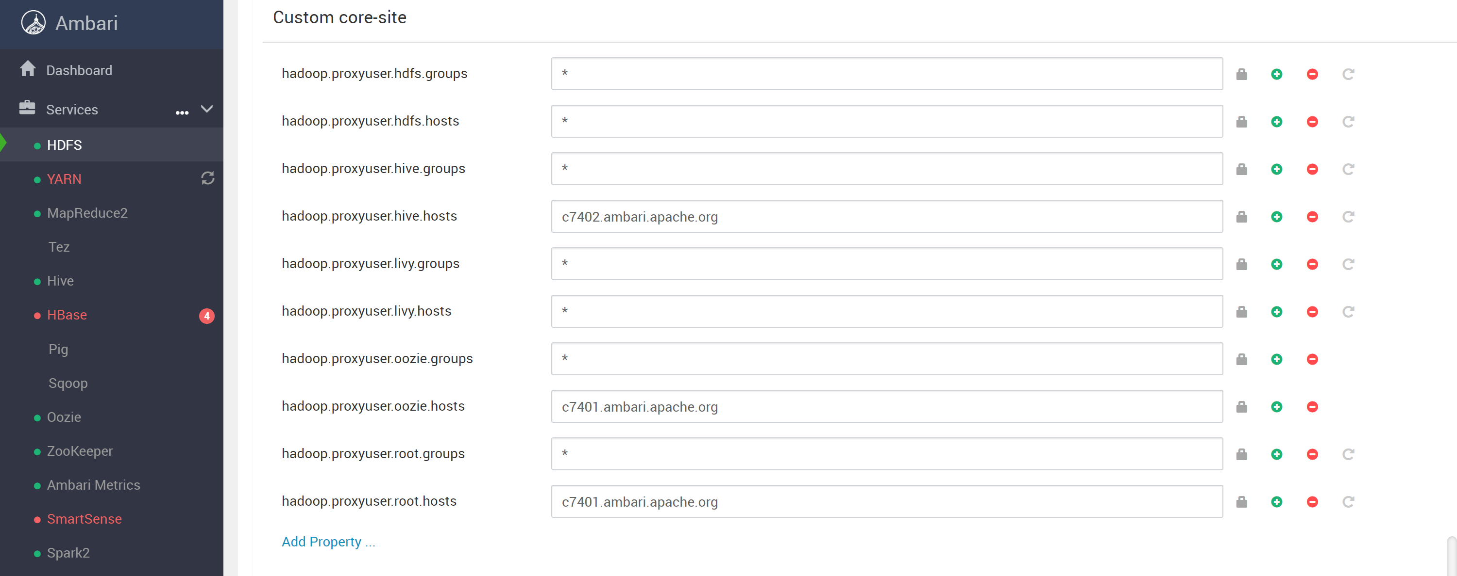

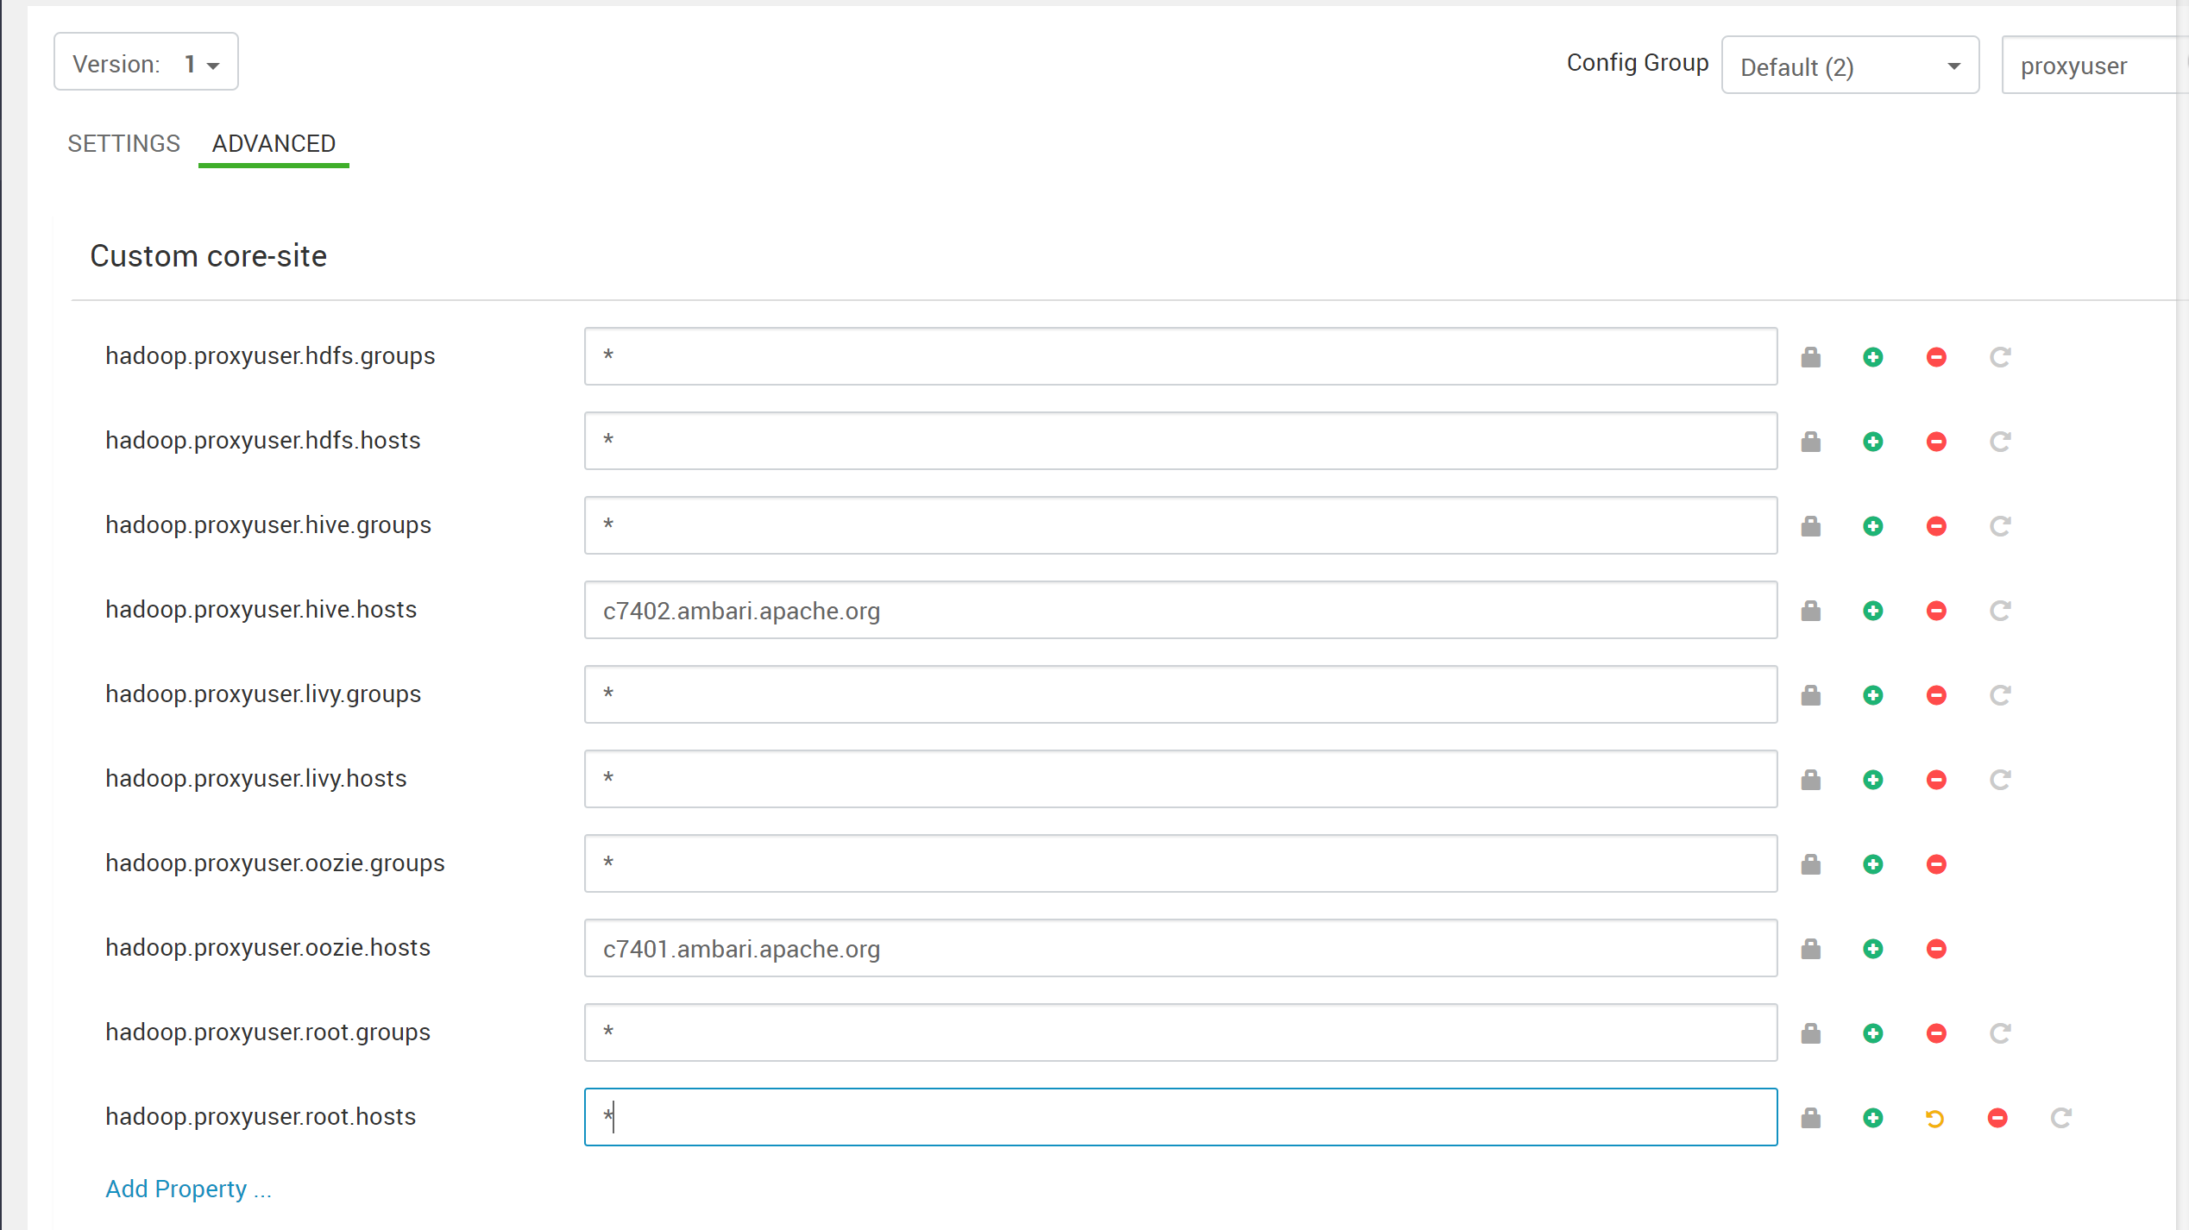

Click Save and continue on.

## Using Superset to access Hive

To install Superset, click on Stacks and Versions to the left.

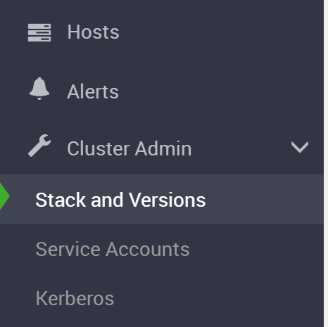

Superset is at the bottom of the page with an Add Service link. Click it. Accept all the defaults and give it a simple password. There will be several pages with default values selected. Click the green Next button until you get to a page called Customize Services.

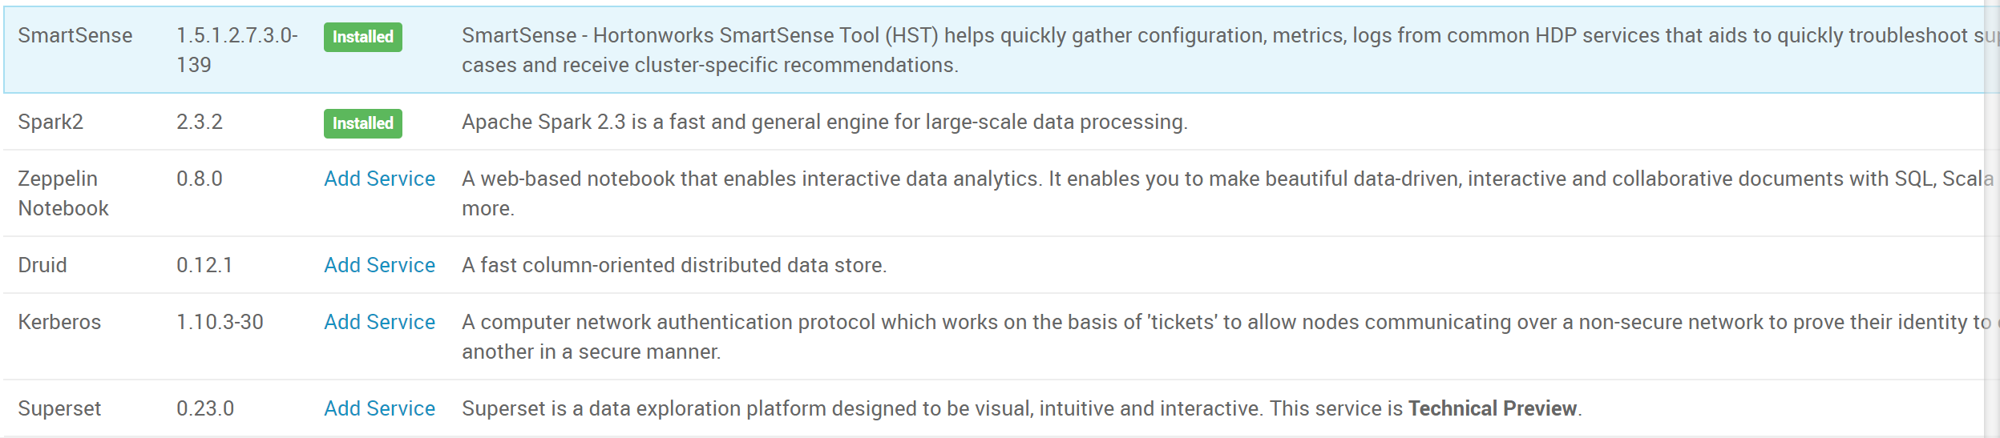

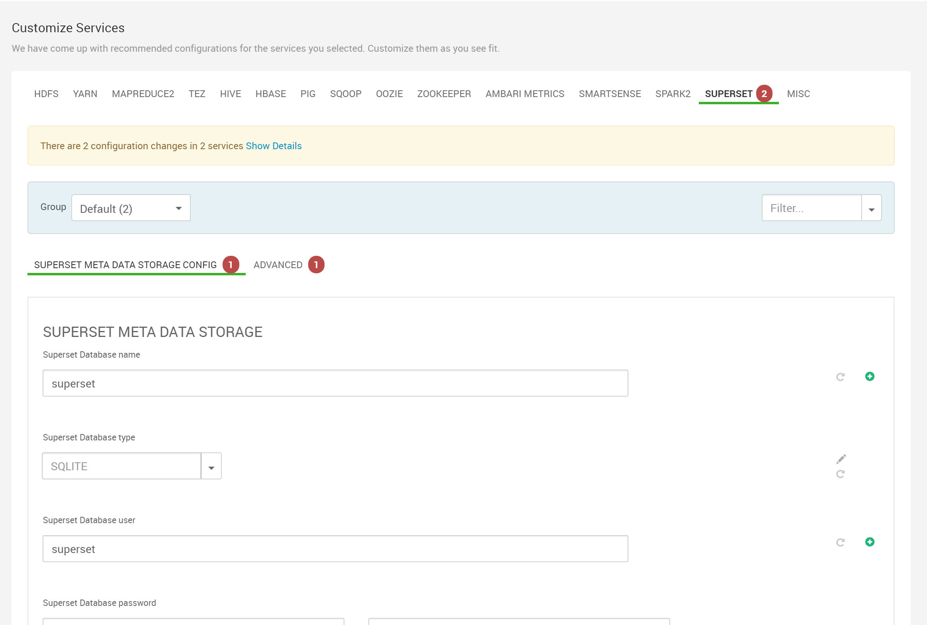

Scroll to the bottom of the page (indicated above) until you see the Attention message. Click on “Show me properties with issues” to enter a secret key and then enter the simple password for Superset (both of these could simply be set to superset).

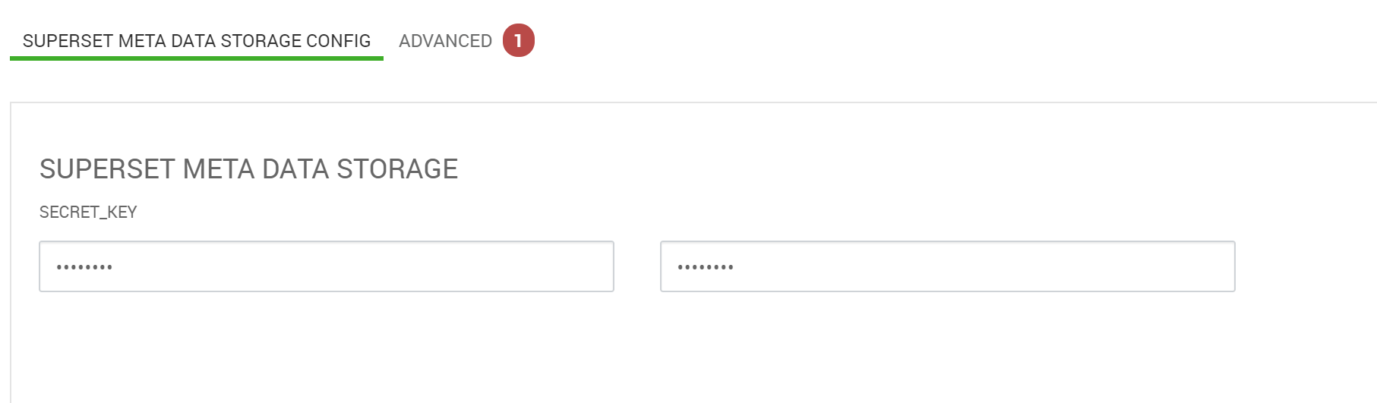

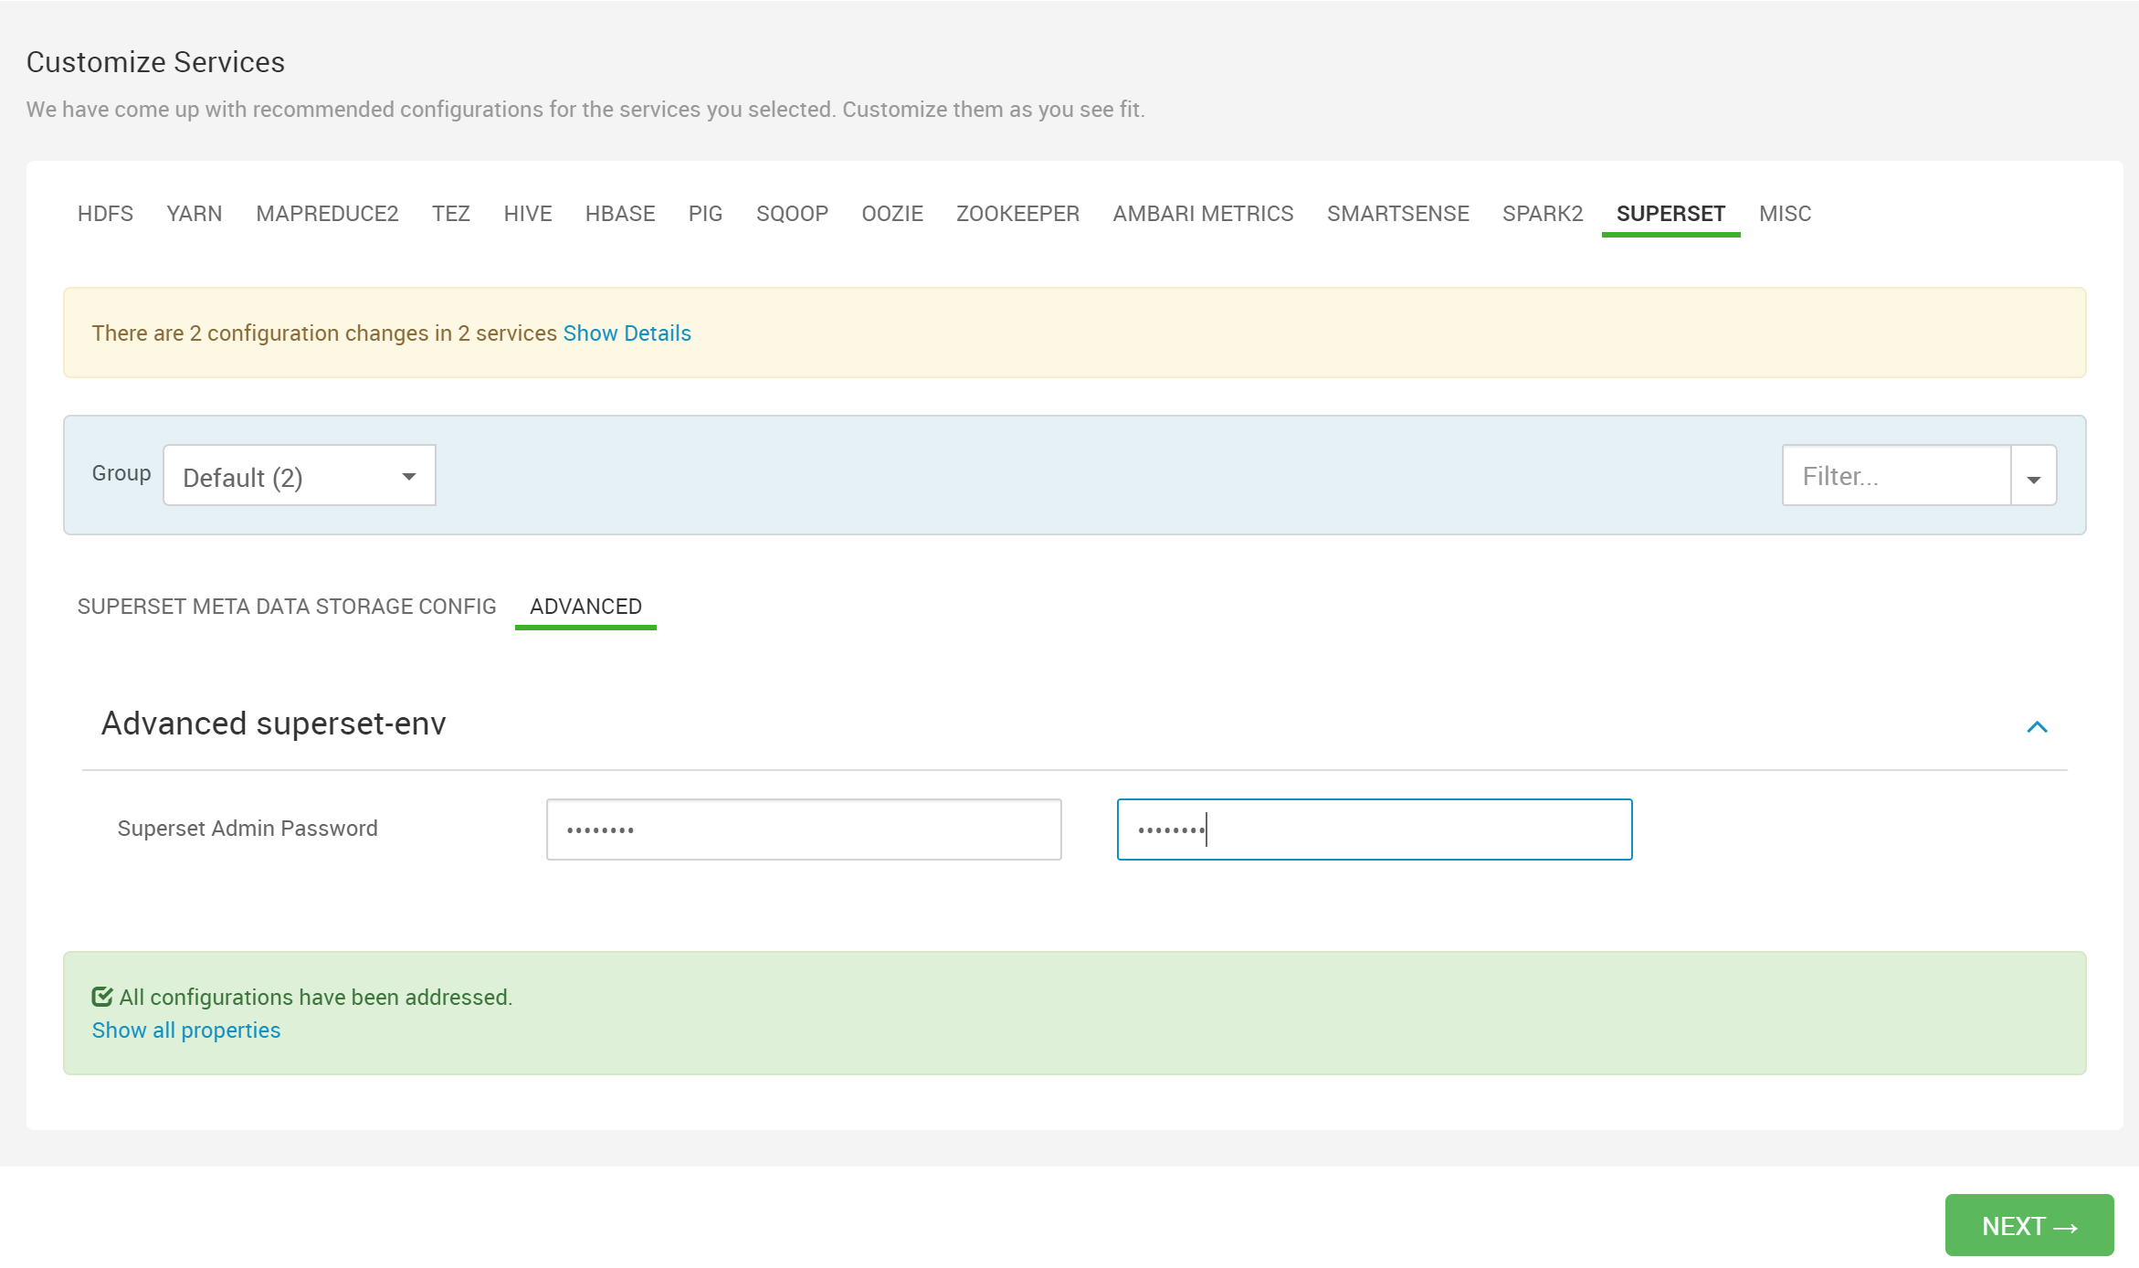

Click the green Next button to proceed.

On the following screen click on the Deploy button at the bottom of the page.

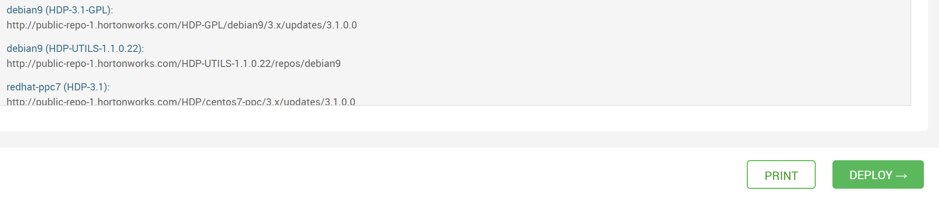

The following screen will indicate the install steps and status.

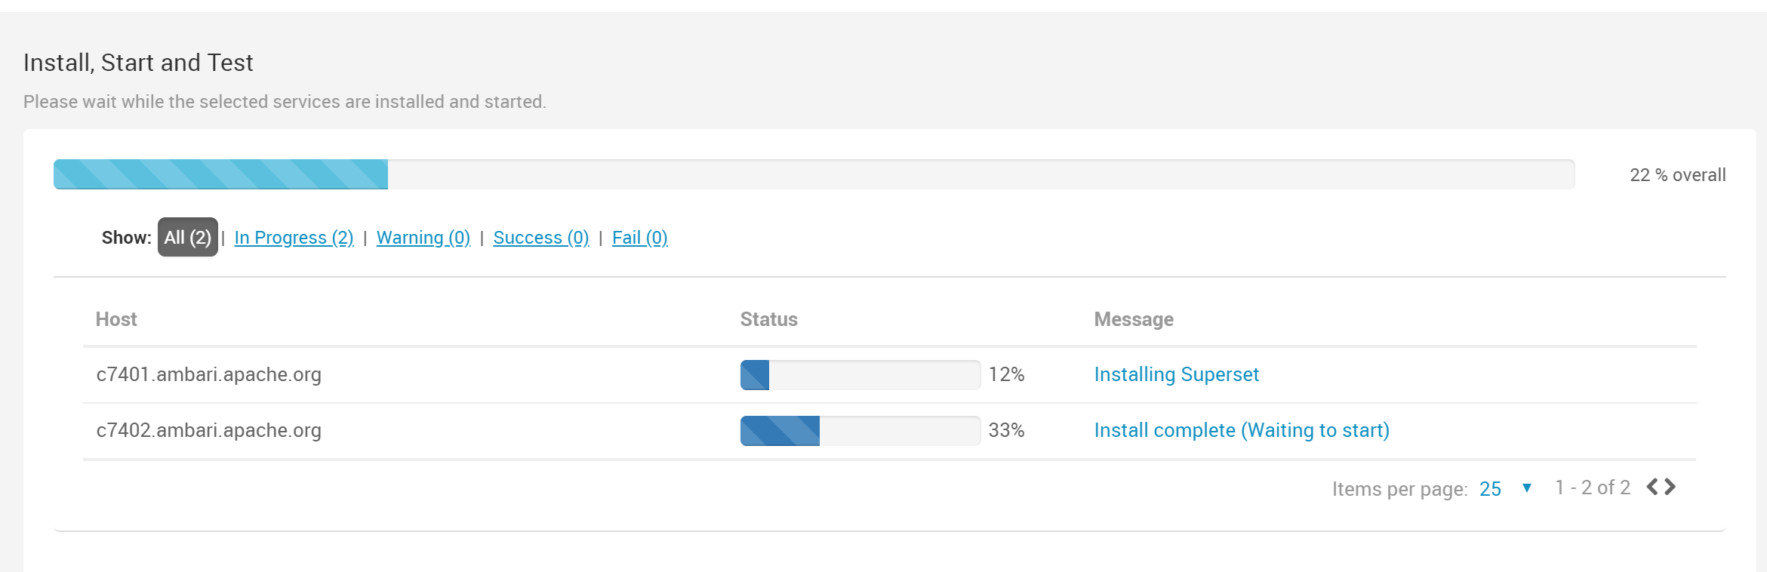

When the install completes you will see the following screen.

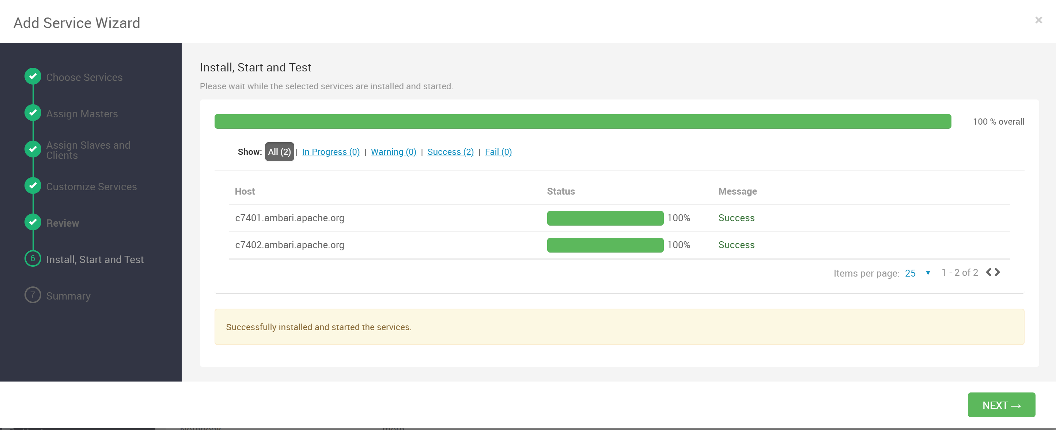

If you are then asked to restart any services, do so now before proceeding. Any services with a “restart” symbol indicated below will need to be restarted.

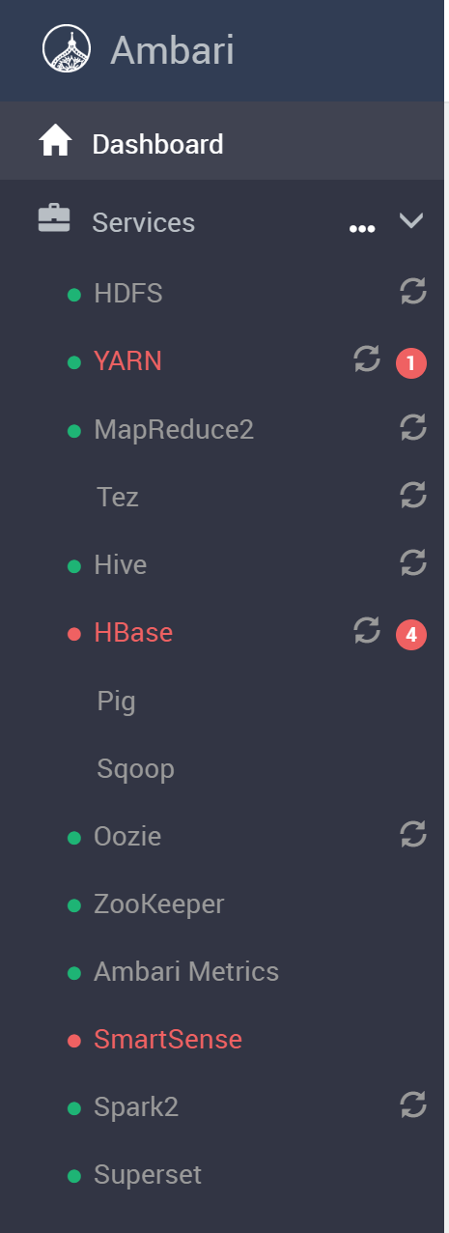

From each service page you can select to “Restart All Affected”. Continue this process until all restart indicators are gone.

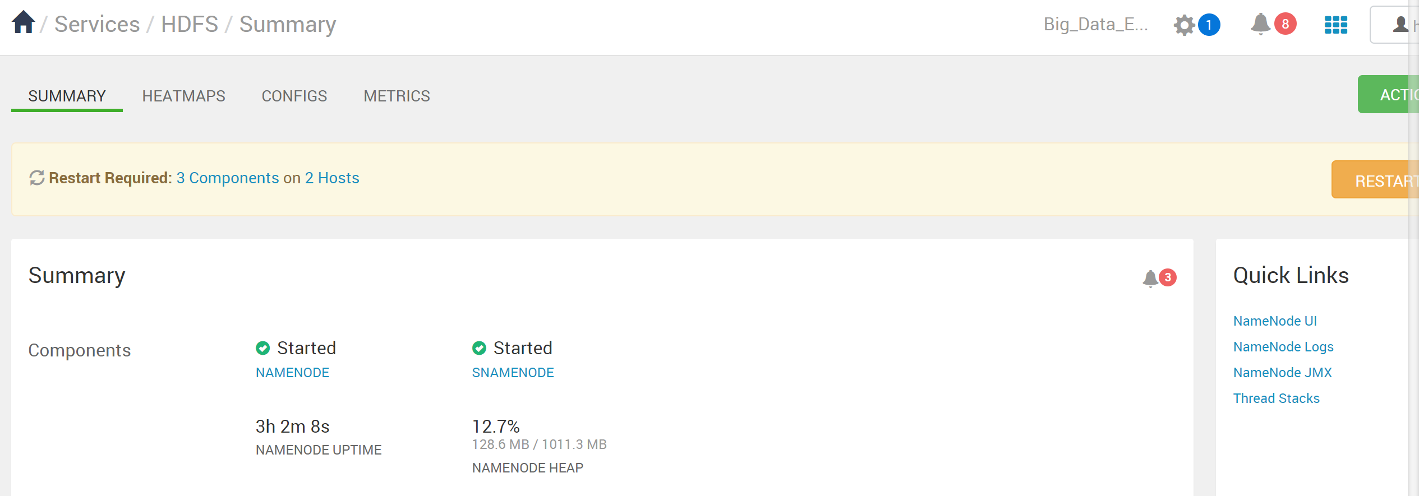

VirtualBox/Vagrant users can enter c7401.ambari.apache.org:9088 into a new browser tab to access the Superset admin page.

Log in with the **admin user and the password** that you set for Superset during the install. (set username and password to superset)

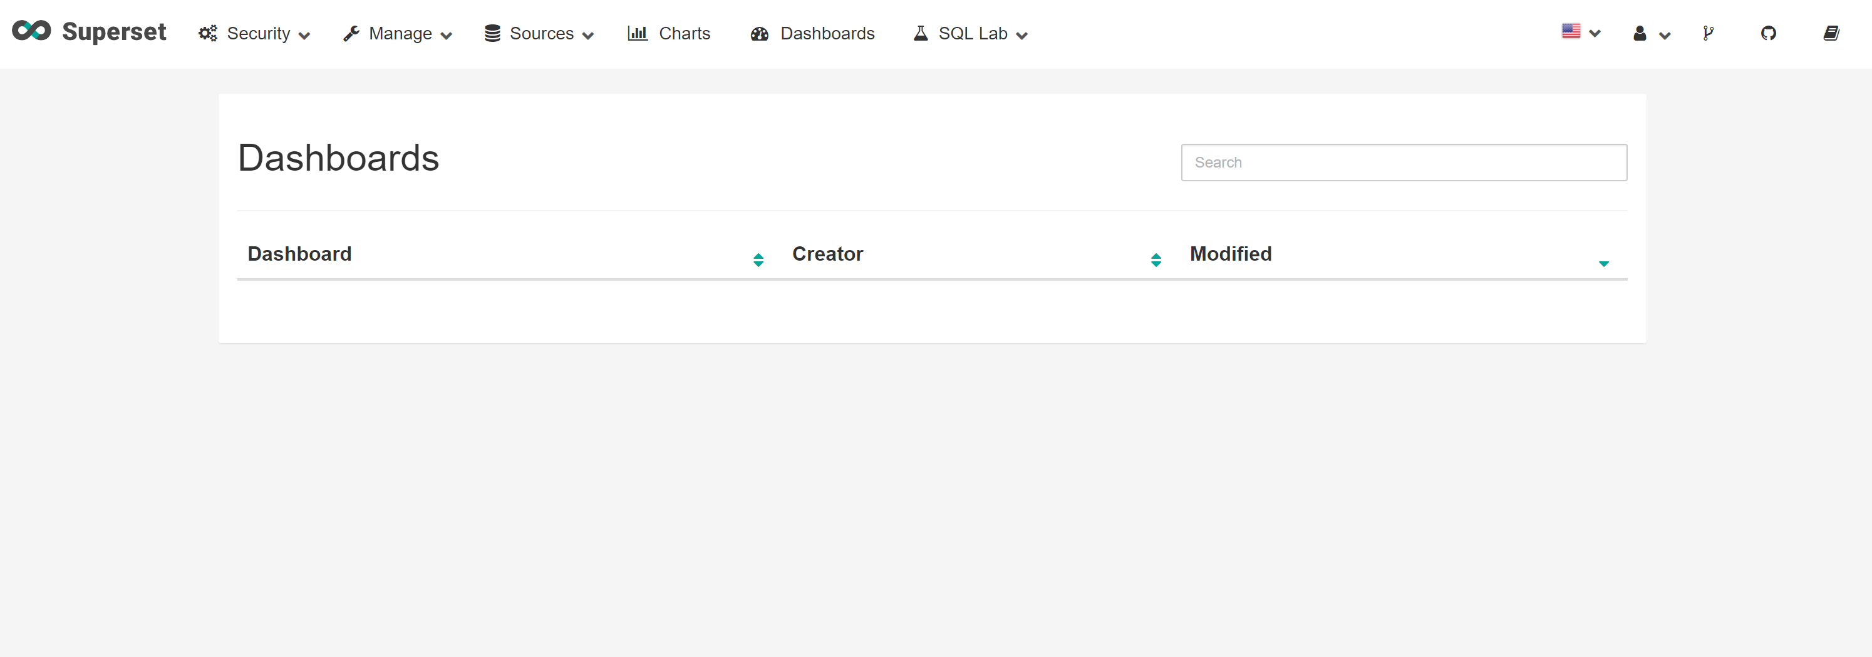

You will see the Superset Dashboards screen, which is rather boring at this point. We will need to connect to **Superset to Hive.** Click the Sources button, then choose Databases.

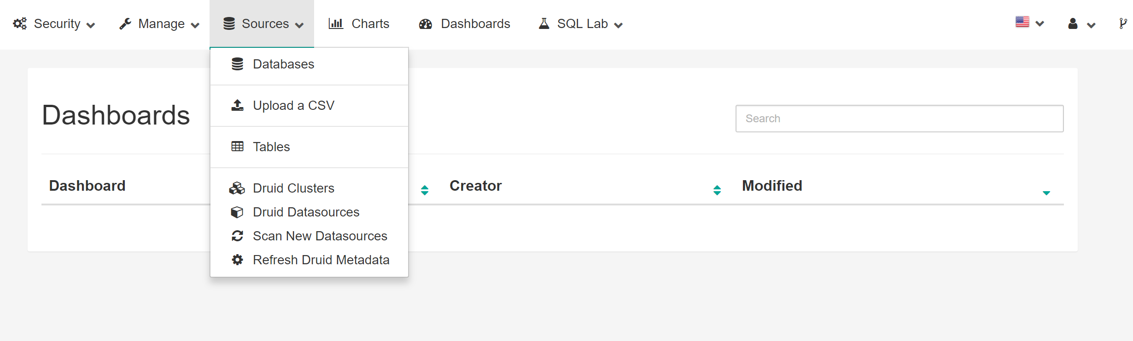

Currently, the only database listed is the one set up during Superset installation. Click the green + to add a database.

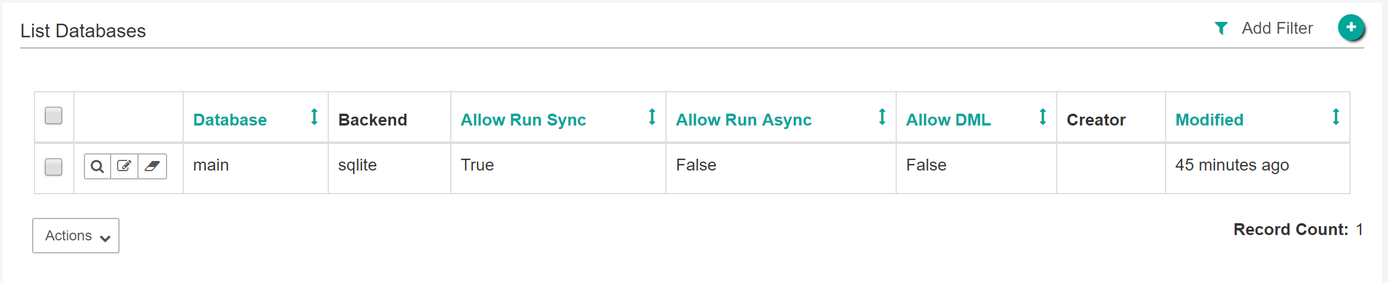

Next, we fill in a name, Hive, for example, and the address of the Hiveserver2 and the server’s port, 10000. **NOTE: the servername for OpenStack users is shown below (manager-2) and the servername for VirtualBox users would be c7402.ambari.apache.org. The two SQL Alchemy URIs are listed below:**

Vagrant users – hive://hive@c7402.ambari.apache.org:10000/default

OpenStack users – hive://hive@manager-2:10000/default

Click on Test Connection

Note: only the OpenStack SQL Alchemy URI is shown below.

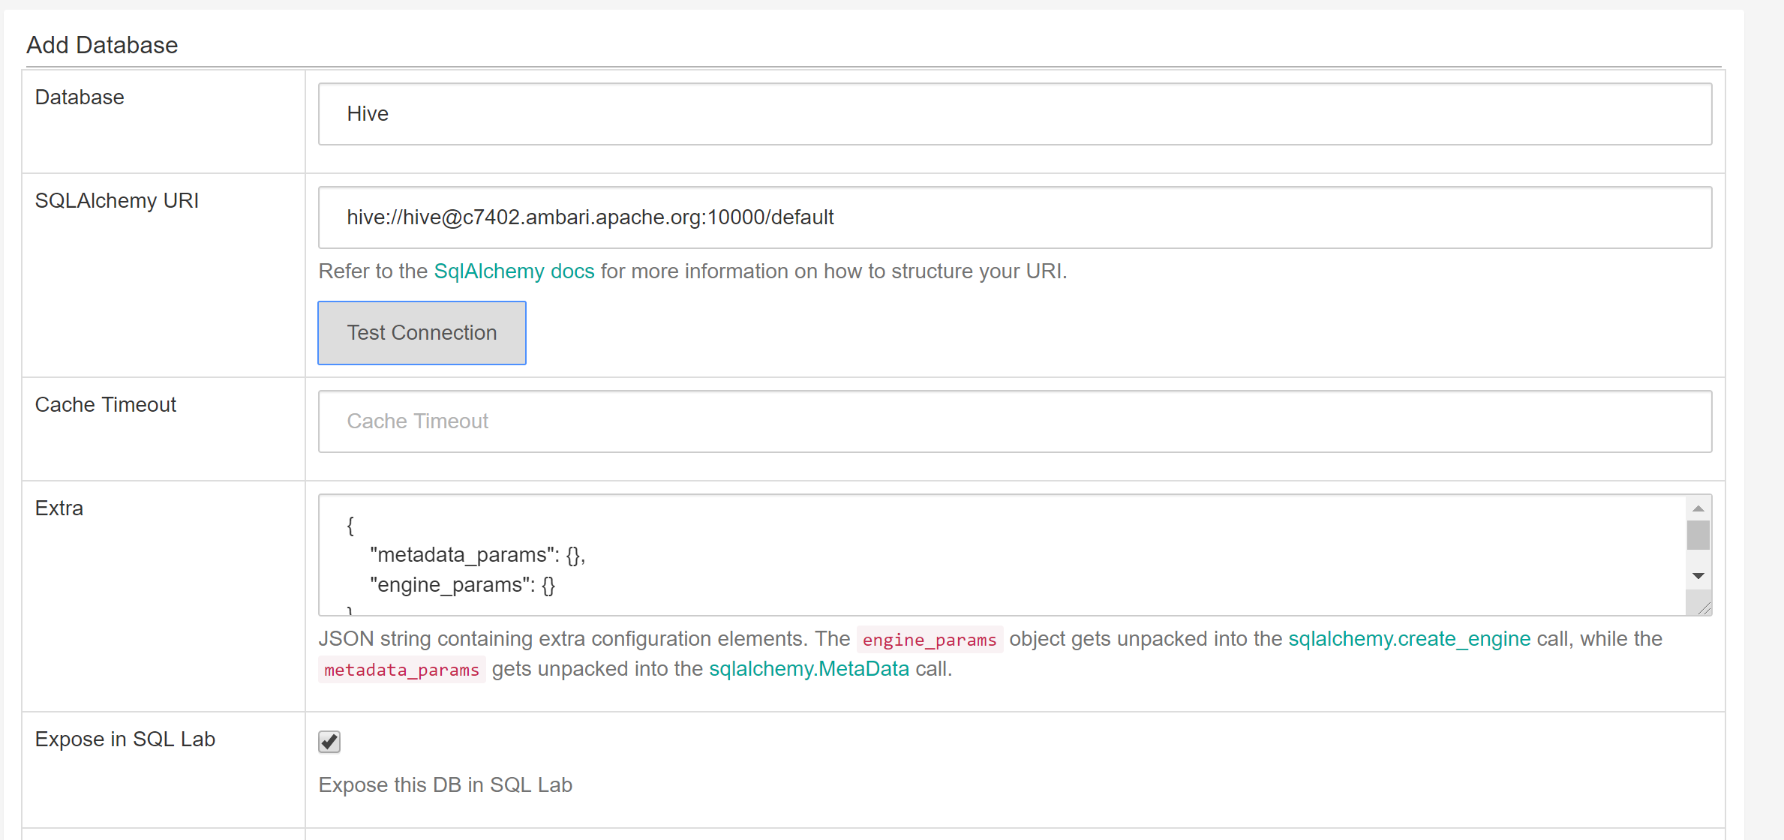

Make sure the Expose in SQL Lab box is checked. Then click Test Connection again.

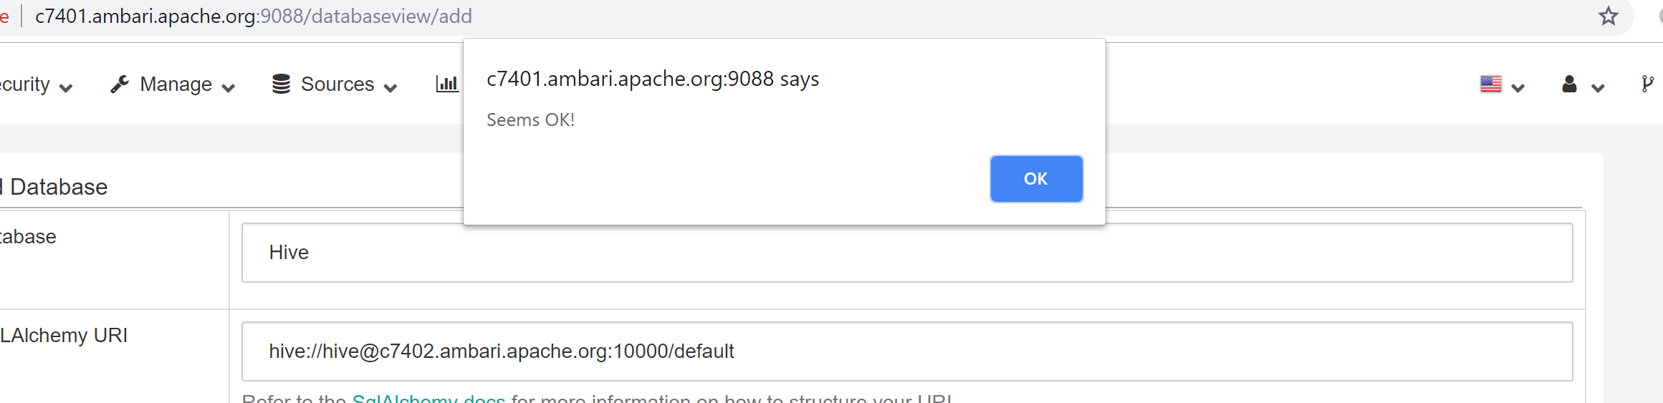

Make sure the Allow DML box is checked so we can create, drop, etc.

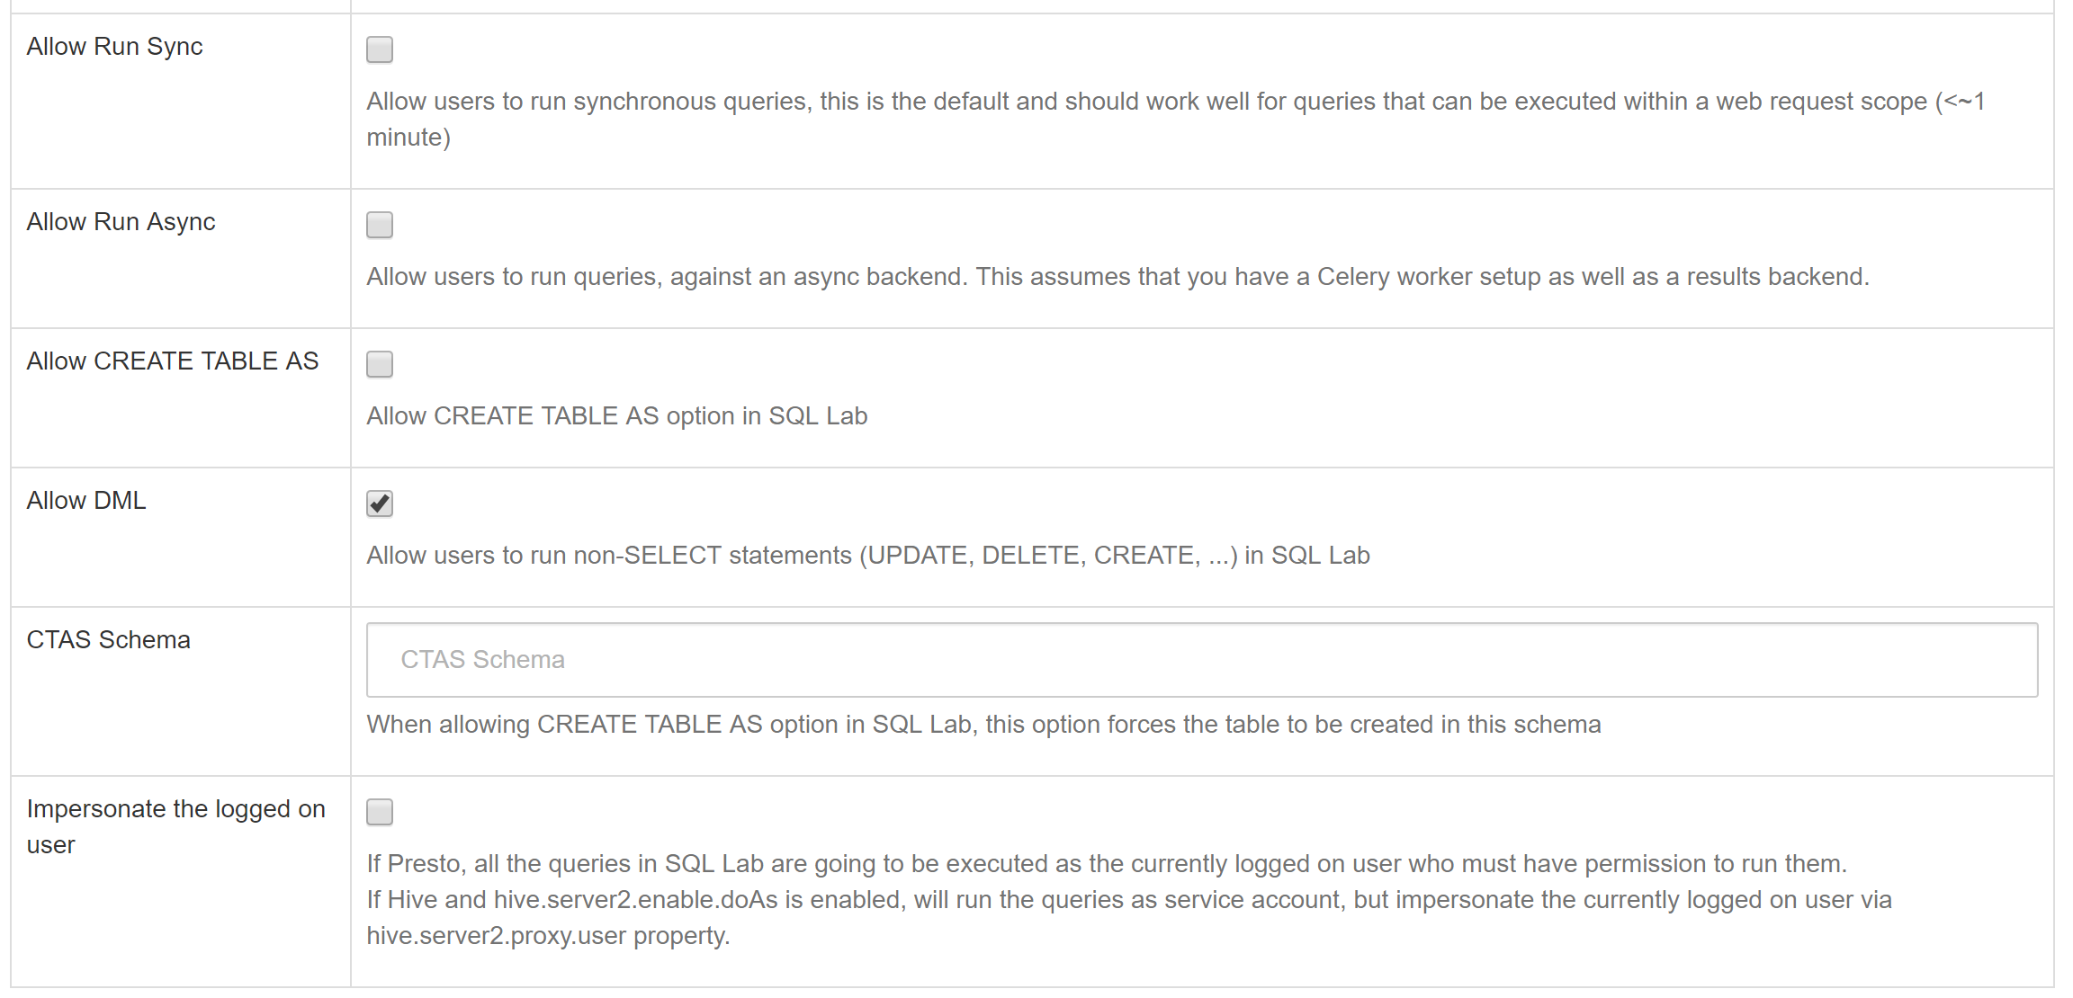

Finally, click the Save button.

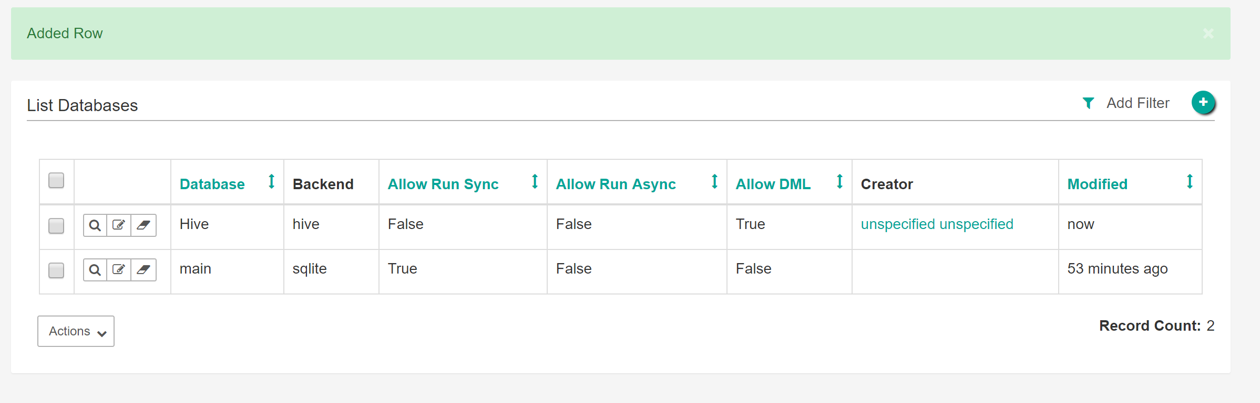

**The result when you return after hitting the save button.**

We’ll use the SQL Editor in the SQL Lab to interact with Hive.

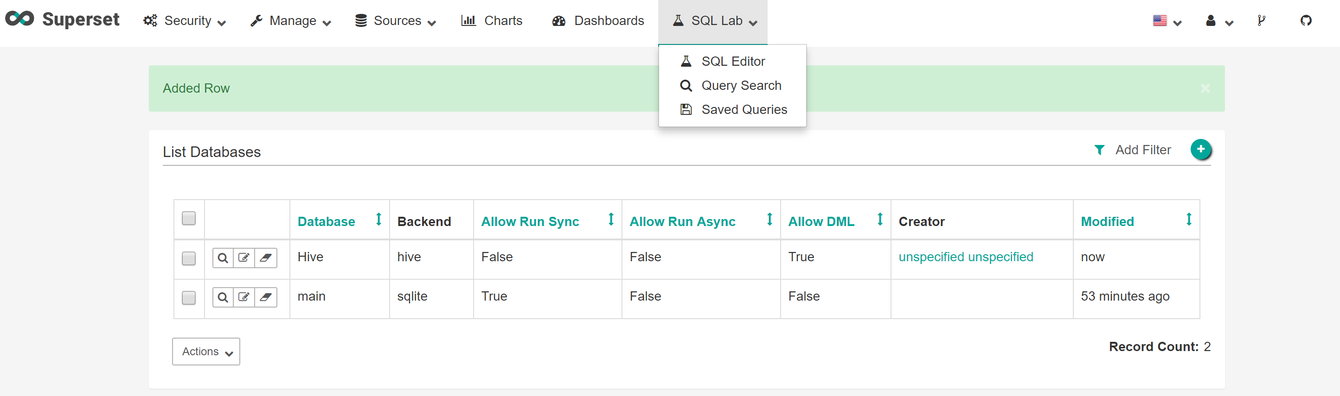

## 1.5 Explore the Superset User Interface

On the left side are dropdowns for choosing database (Hive), schema, and table. When you have created a table (next section), you can select it and see the column names and types. The first 50 rows will show up in the Preview area.

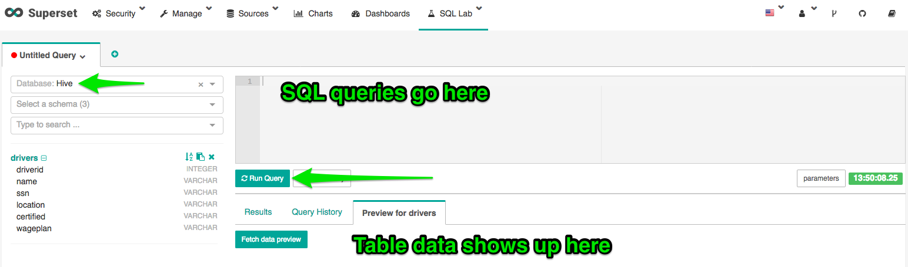

### Hive and Pig Data Model Differences

Before we get started let’s take a look at how Pig and Hive data models differ. In the case of Pig all data objects exist and are operated on in the script. Once the script is complete all data objects are deleted unless you stored them. In the case of Hive, we are operating on the Apache Hadoop data store. Any query you make, table that you create, data that you copy persists from query to query. You can think of Hive as providing a data workbench where you can examine, modify and manipulate the data in Apache Hadoop. So, when we perform our data processing task we will execute it one query or line at a time. Once a line successfully executes you can look at the data objects to verify if the last operation did what you expected. **All your data is live, compared to Pig, where data objects only exist inside the script unless they are copied out to storage.** This kind of flexibility is Hive’s strength. You can solve problems bit by bit and change your mind on what to do next depending on what you find.

## 1.6 Upload Data Files to HDFS

If you haven’t already downloaded and unzipped the data file from WorldClass, do so now and make note of where you unzip it. You will need that location in a few minutes.

**Go back to you Ambari session. Open up the files view within Ambari by clicking on the options menu and select File Views.**

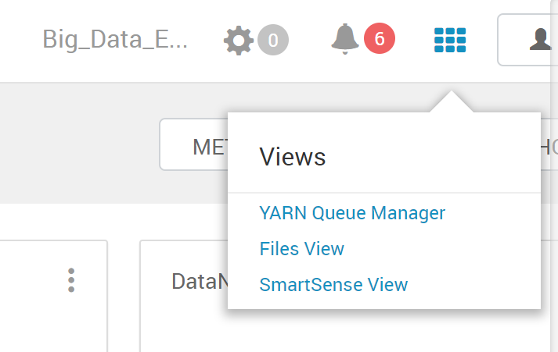

**The File view will open. Click on the user directory.**

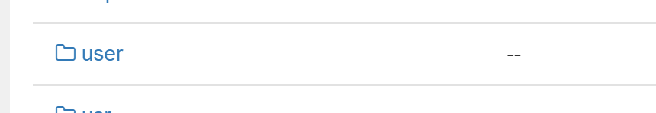

**Click on the admin folder:**

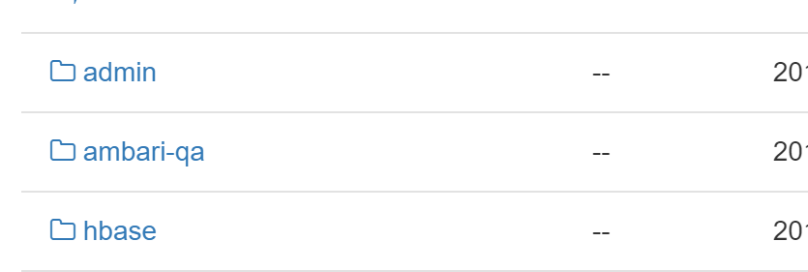

**Once you are located in the admin directory, click the Upload button at the top, right of the screen.**

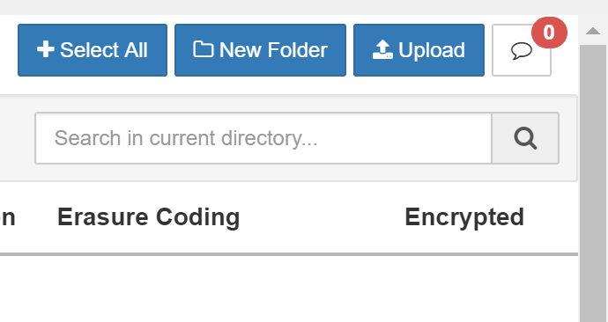

**Drag the drives.csv from Finder or Windows Explorer and drop it into the upload box, as shown below: (Can also navigate to it and upload the file)**

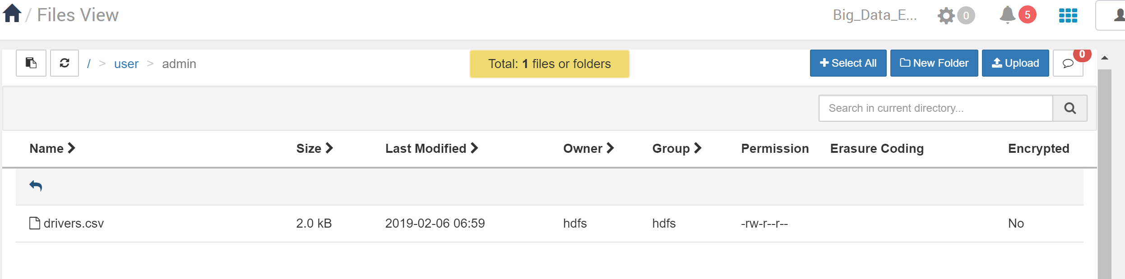

Do the same process for the remaining csv’s so all three files are uploaded to the /user/admin folder for use later (as shown below). We will only use two for the lab though.

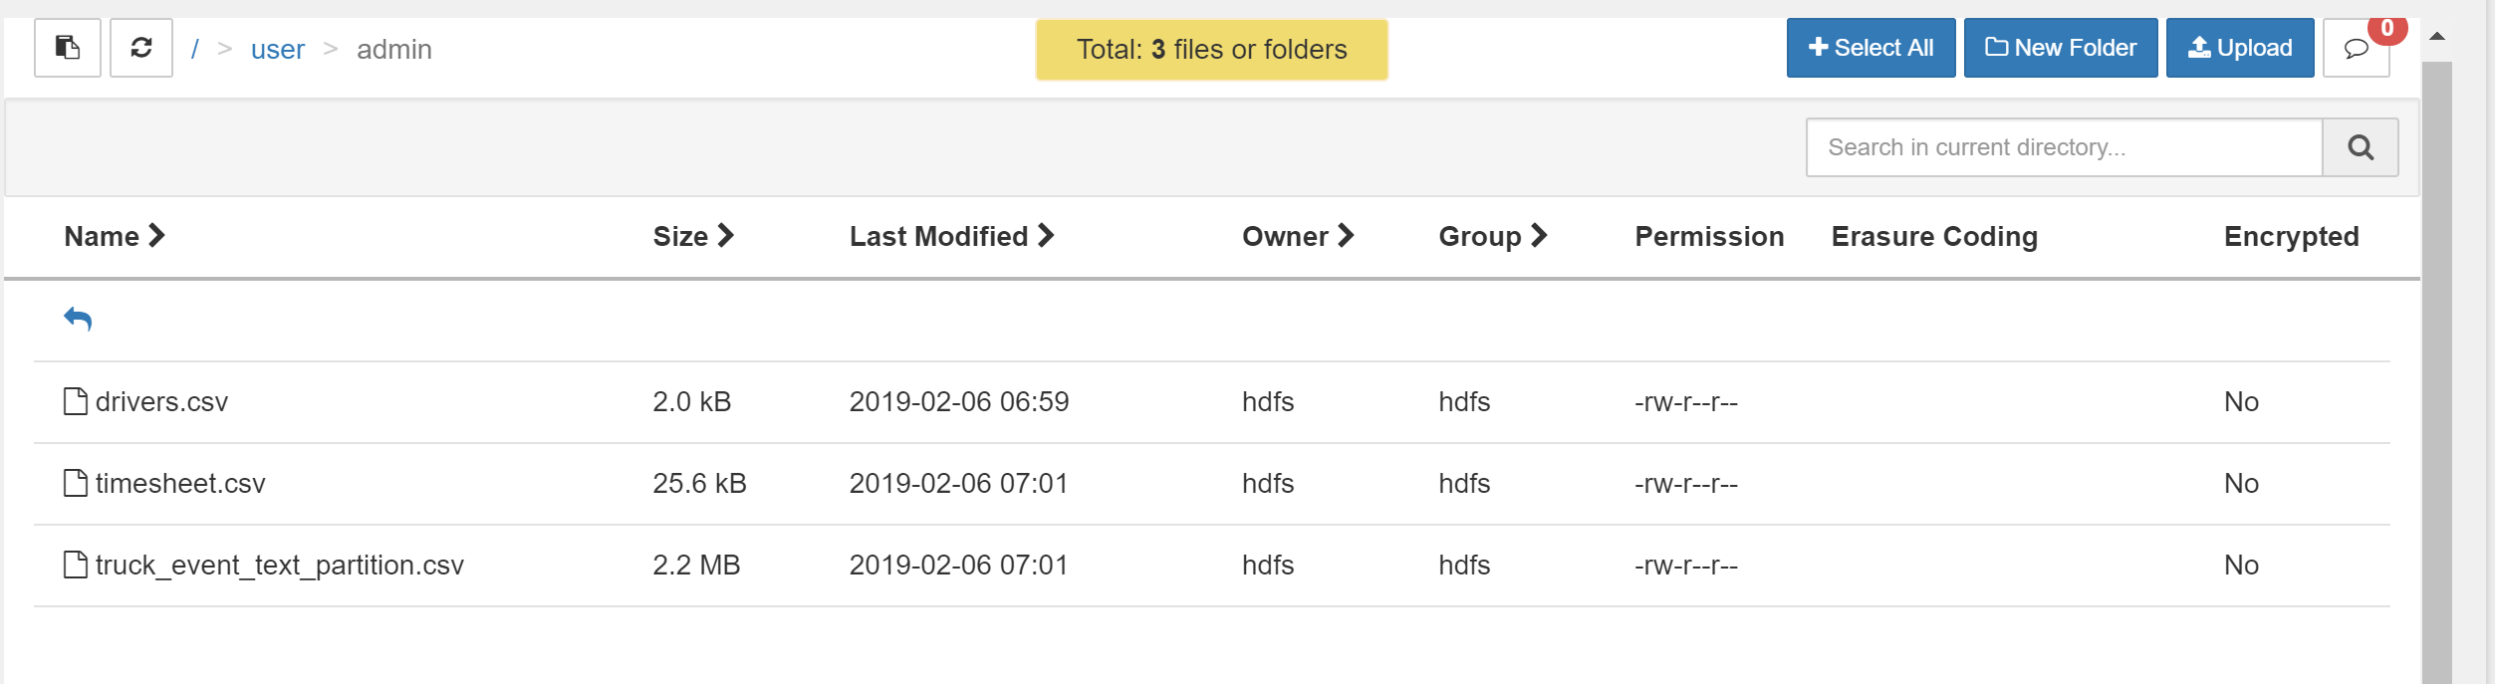

Set the file permissions to Read, Write, Execute for everyone, just like you did with the admin folder. The next screenshot only shows the drivers.csv file, **but do the same thing for all 3.**

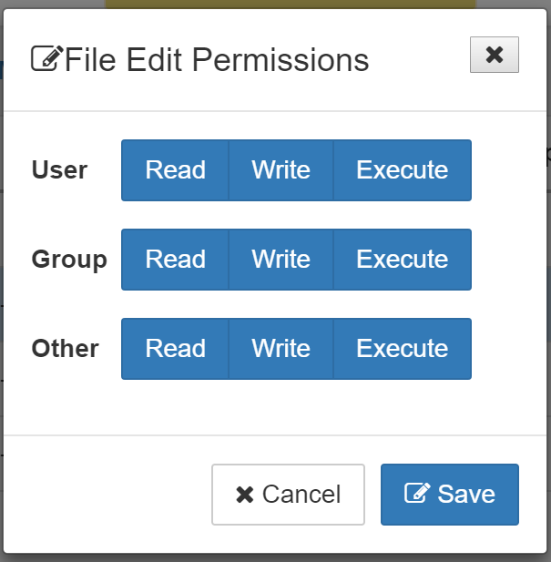

## 1.7 Creating Tables and Loading Data

Back in Superset, go to the SQL Editor (under SQL labs).

We are going to create the drivers table first.

create table drivers (

driverId INT,

name STRING,

ssn STRING,

location STRING,

certified STRING,

wageplan STRING)

row format delimited fields terminated by ‘,’

stored as textfile tblproperties(“skip.header.line.count”=”1”)

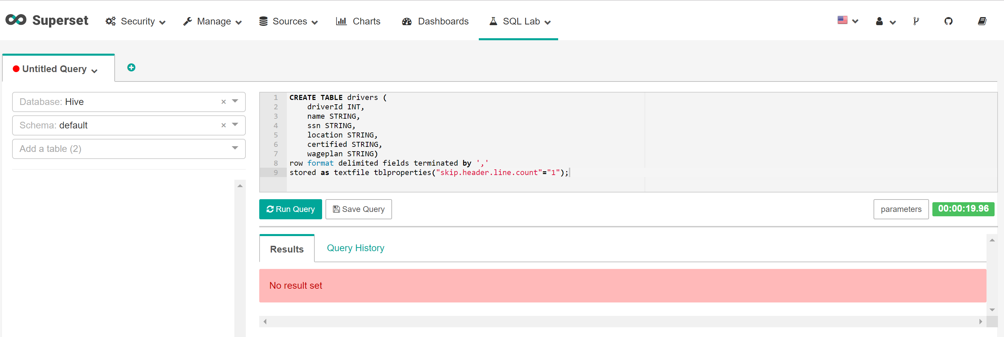

**Hive stores tables as files on HDFS called ORC files (Optimized Row Columnar file).** However, since we are reading a CSV file (text file) we are telling Hive to store as a text file format, with the ‘,’ as field delimiter. Finally, we tell Hive to skip the first row which contains names in the CSV file.

The scary-looking, red “No result set” just means our create table query didn’t return any rows like a SELECT statement would.

Next, we need to load the data from the field into the table. Delete the SQL in the editor and enter the following.

Load data inpath ‘/user/admin/drivers.csv’ overwrite into table drivers

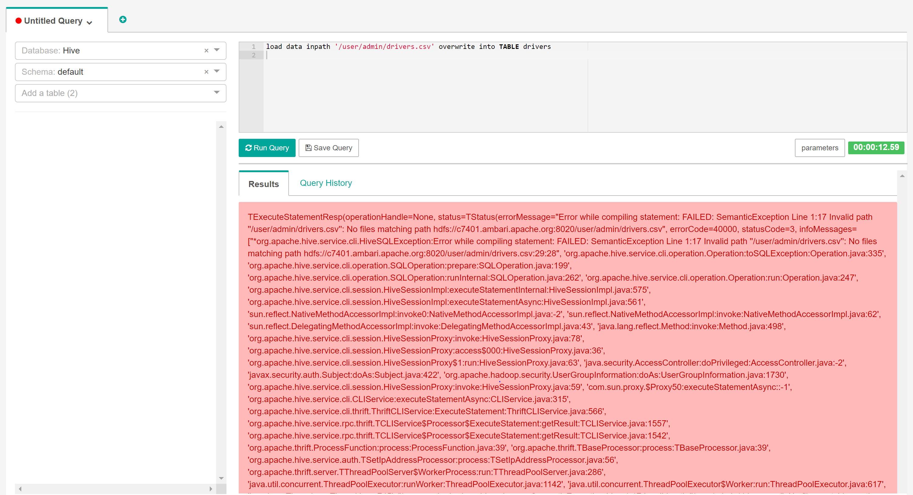

**Originally when I ran the command to load the data into driver my system timed out after 30 seconds, so I re-ran the command and got the error above. After freaking out and checking a bunch of different systems I decided to run the command below and was thankfully reassured the drivers table was populated with the proper data.**

**SELECT \***

**FROM drivers;**

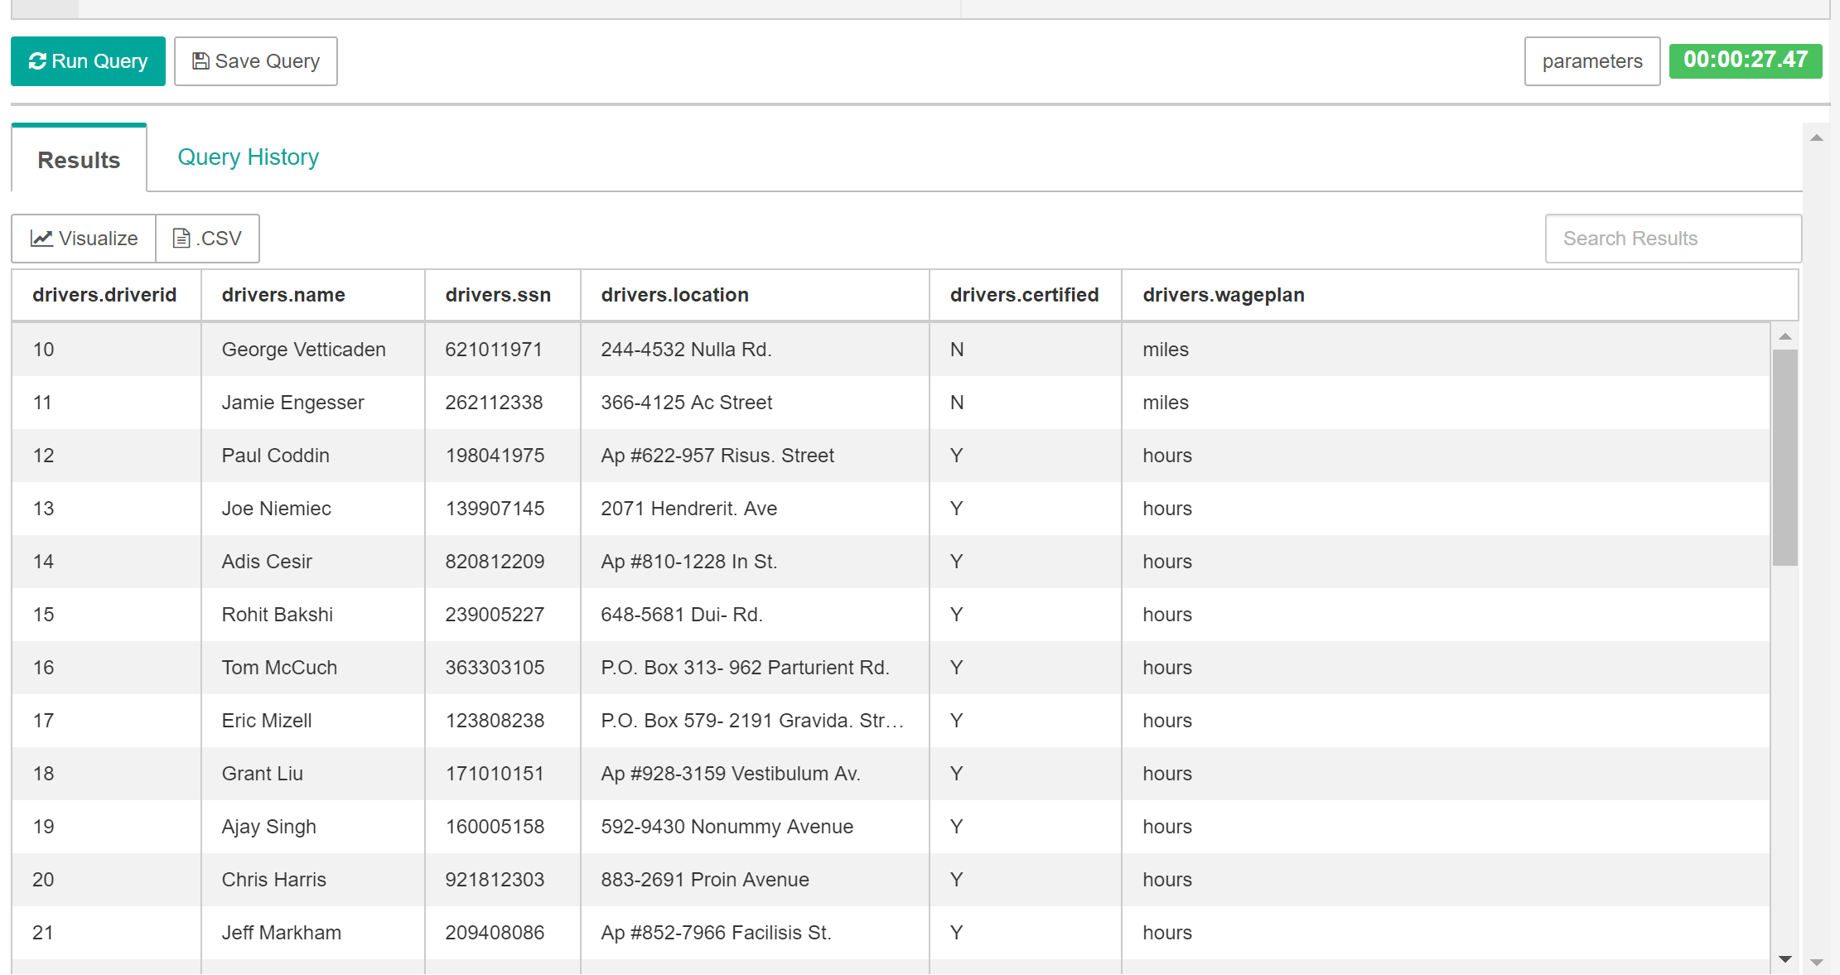

On the left side of the SQL edit box, choose Hive, Default, Drivers from the three dropdown boxes.

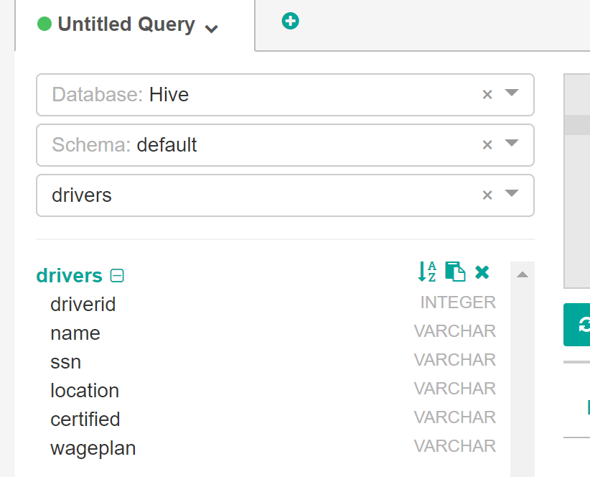

If the data is loaded successfully, you will see data in the Preview for drivers area.

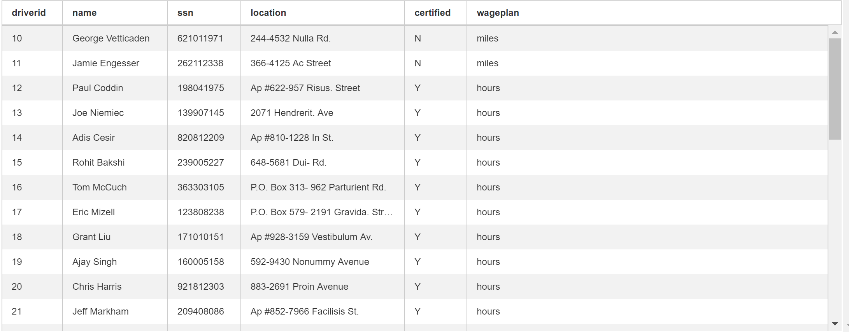

**Creating the TIMESHEET table:**

Create the timesheet table and then load the sample timesheet.csv file. Run the following queries:

create table timesheet (

driverId INT,

week INT,

hourslogged INT,

mileslogged INT)

row format delimited fields terminated by ‘,’

stored as textfile tblproperties(“skip.header.line.count”=”1”)

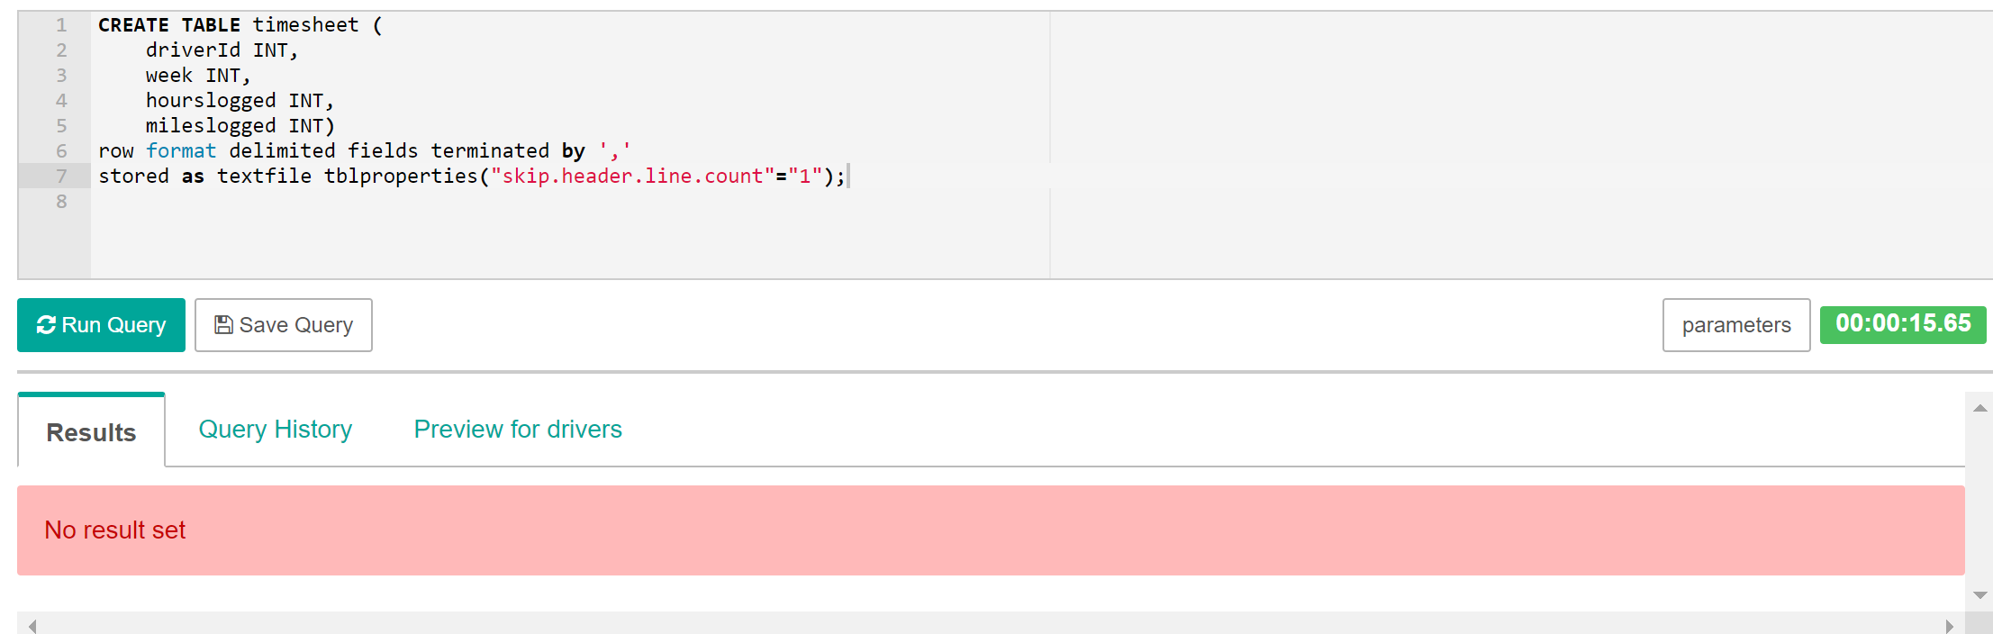

Now delete the last SQL statement from the SQL window and load the data as shown below.

load data inpath ‘/user/admin/timesheet.csv’ overwrite into table timesheet

**I had a similar error as I did with the drivers table, so I ran the SELECT * FROM timesheet; query to make sure the table had infact loaded and was populated into the timesheet table.**

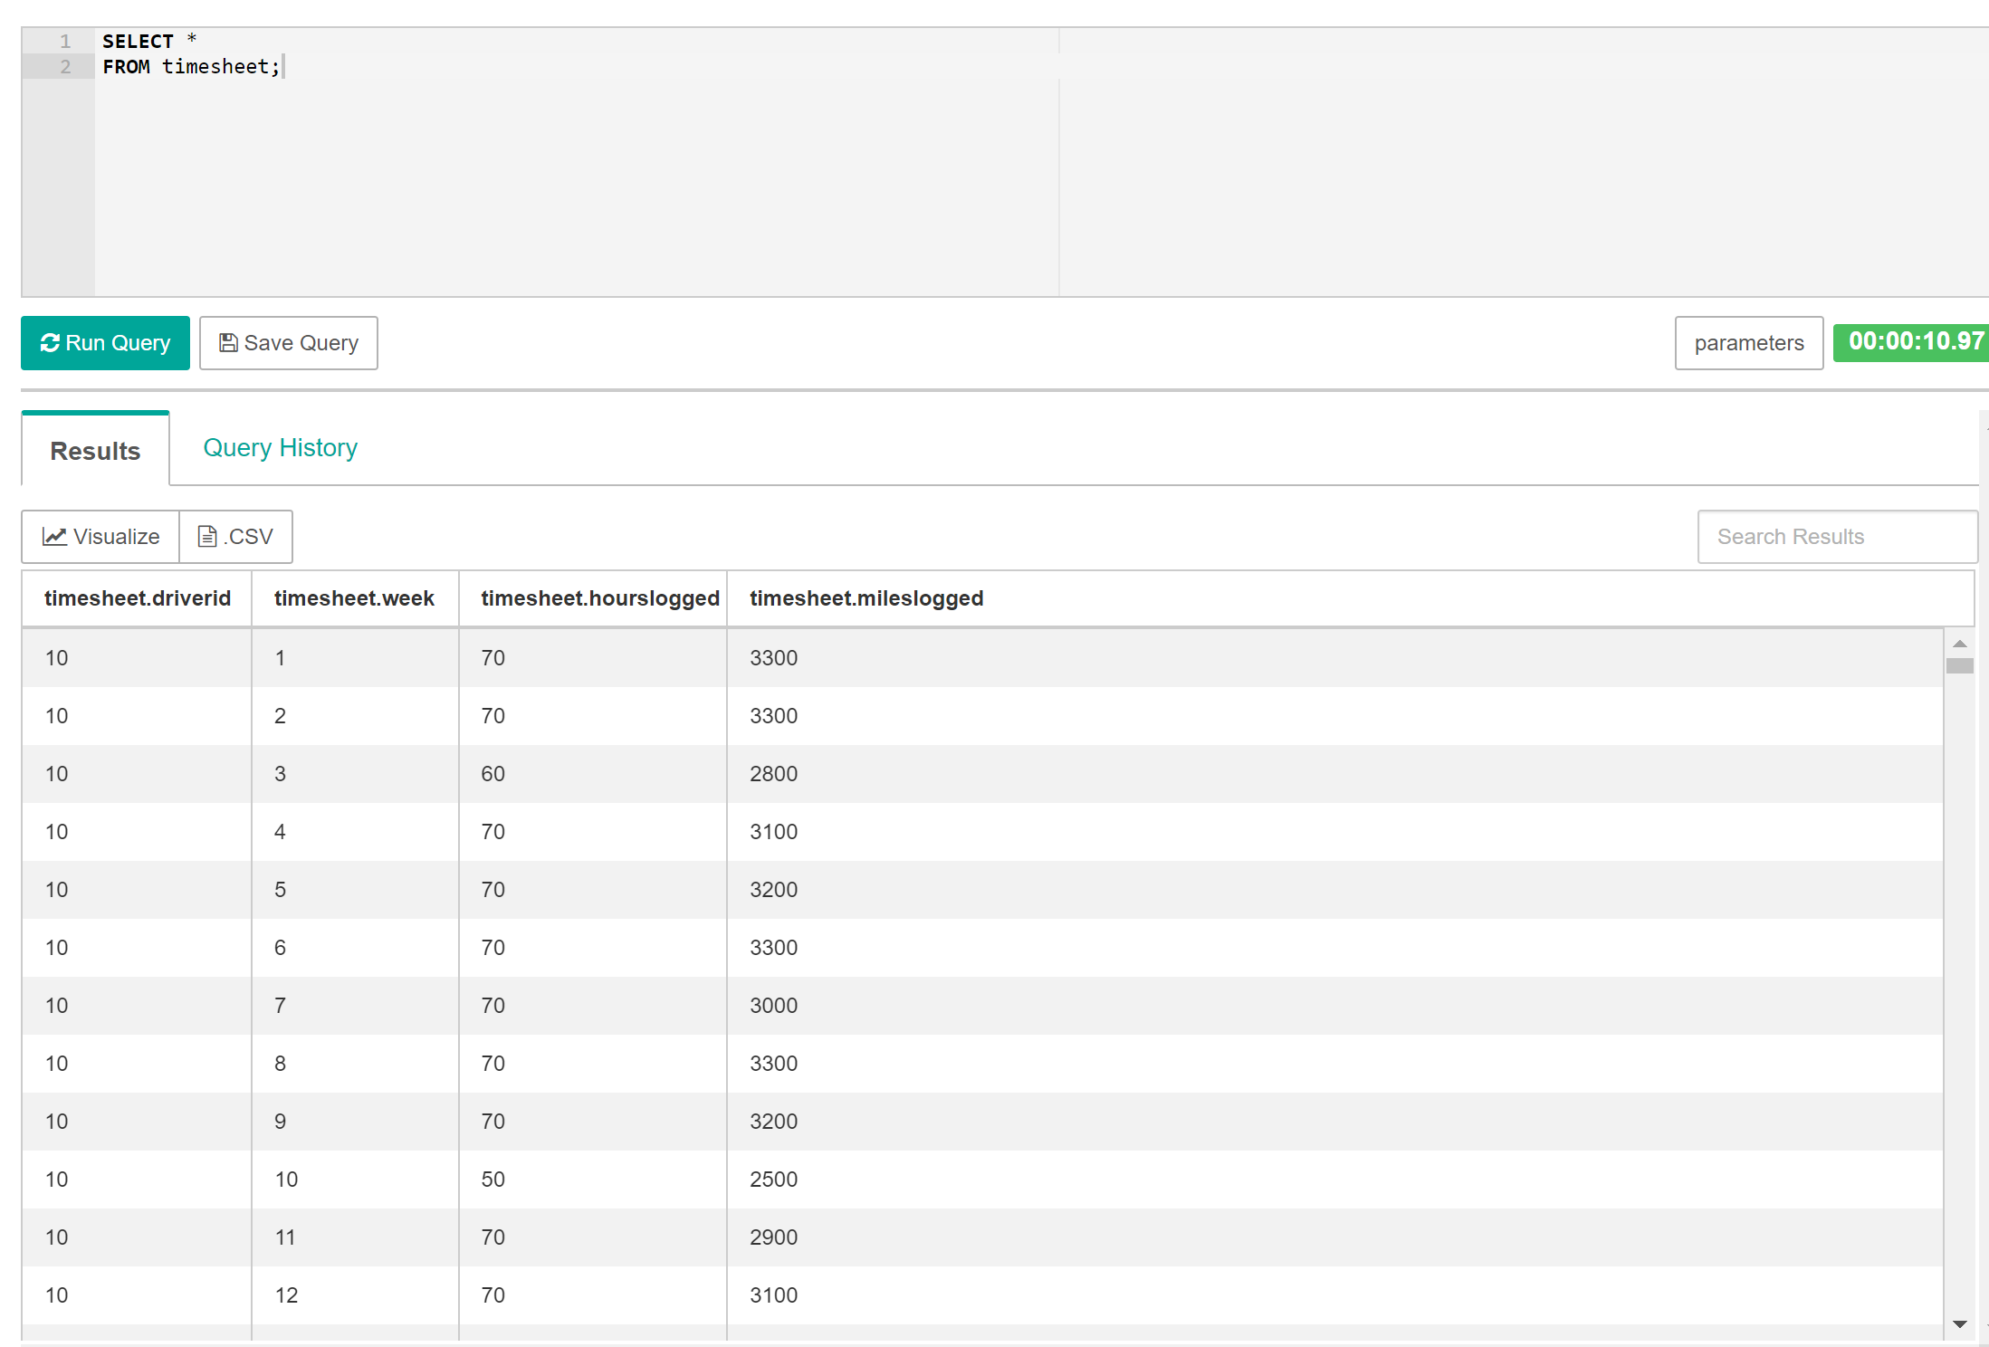

On the left side you will need to select the default schema again to get the table date to refresh. After you select timesheet you will see a preview of the timesheet table.

## 1.8 Query Data

Now we have the data fields we want. The next step is to group the data by driverId so we can find the sum of hours and miles logged score for a year. This query first groups all the records by driverId and then selects the driver with the sum of the hours and miles logged runs for that year.

**Note:** If the query listed below times out see directions in the **Appendix** section below!

SELECT driverid,

sum(hourslogged),

sum(mileslogged)

FROM timesheet

GROUP BY driverid

**The result of the query looks like this:**

**Unfortunately for me the query would exceed the 30 seconds threshold and timeout, so I had to use what is in the appendix section to complete this query.**

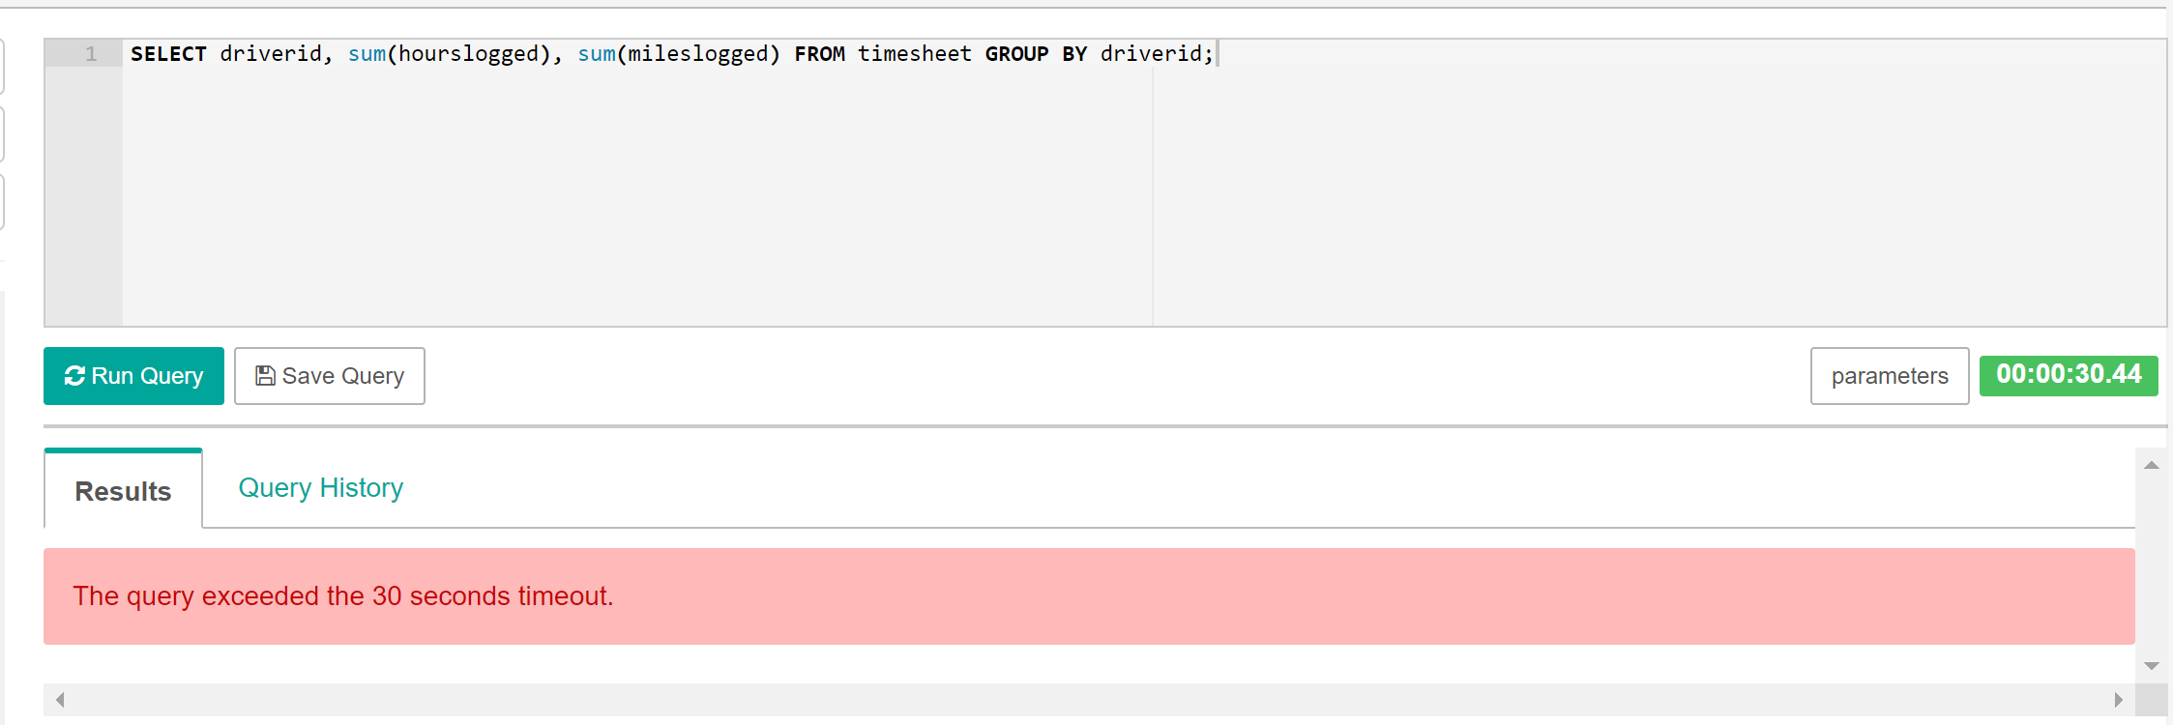

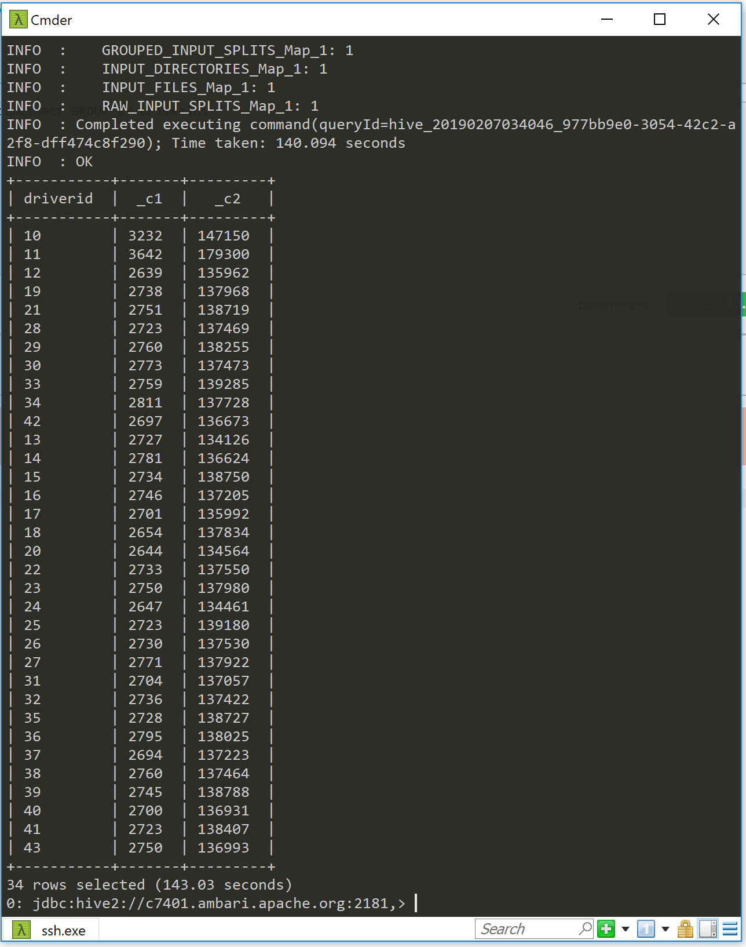

**CREATE QUERY TO JOIN THE DATA (DRIVERID, NAME, HOURS_LOGGED, MILES_LOGGED)**

Now we need to go back and get the driverId(s) so we know the driver(s) was. We can take the previous query and join it with the drivers records to get the final table which will have the driverid, name and sum of hours and miles logged.

**Note:** If the query listed below times out see directions in the **Appendix** section below. **(Used this to complete the first query)**

**I’m going to attempt to create the following query within the Superset environment but if I time out again I will go back and complete the query in Cmder.**

SELECT d.driverid,

d.name,

t.totalhours,

t.totalmiles,

FROM drivers d

JOIN (SELECT driverid, sum(hourslogged)totalhours, sum(mileslogged)totalmiles

FROM timesheet

GROUP BY driverid ) t

ON (d.driverid=t.driverid)

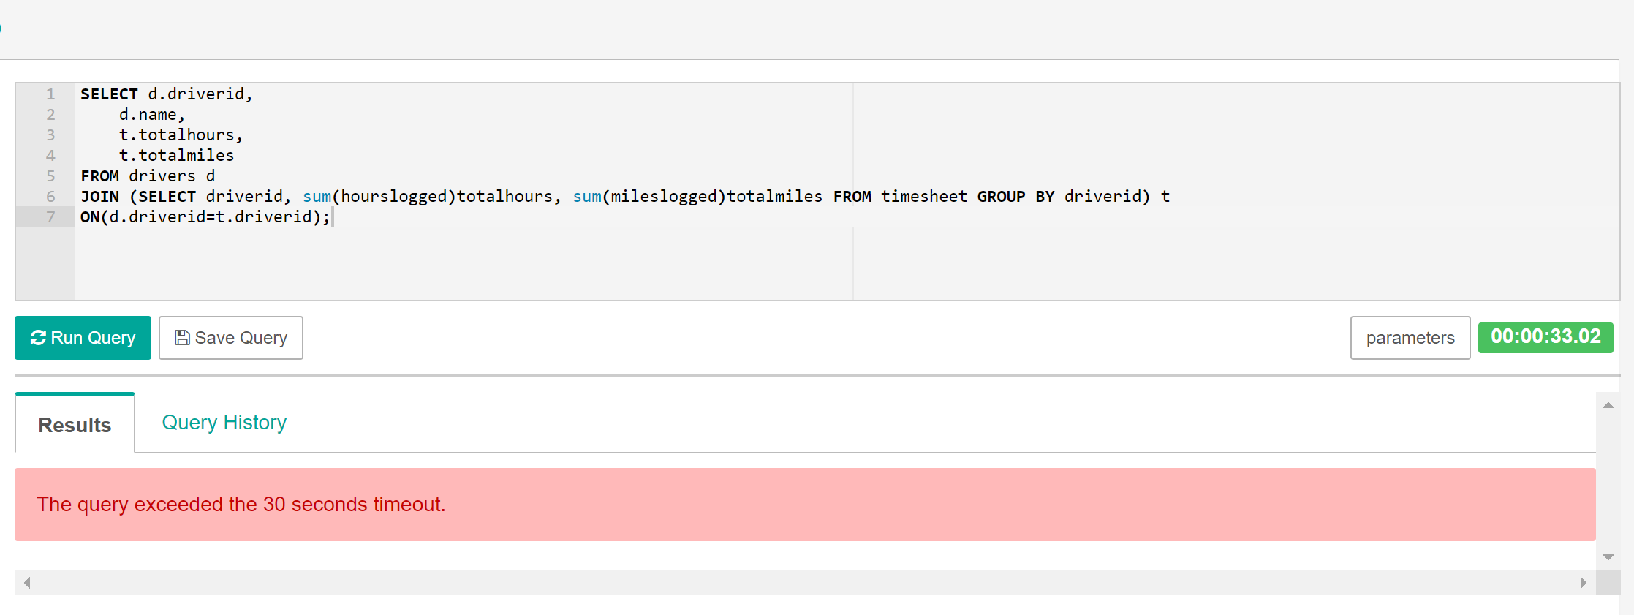

**Since the query once again timed out I will be completing this query in the Cmder prompt.**

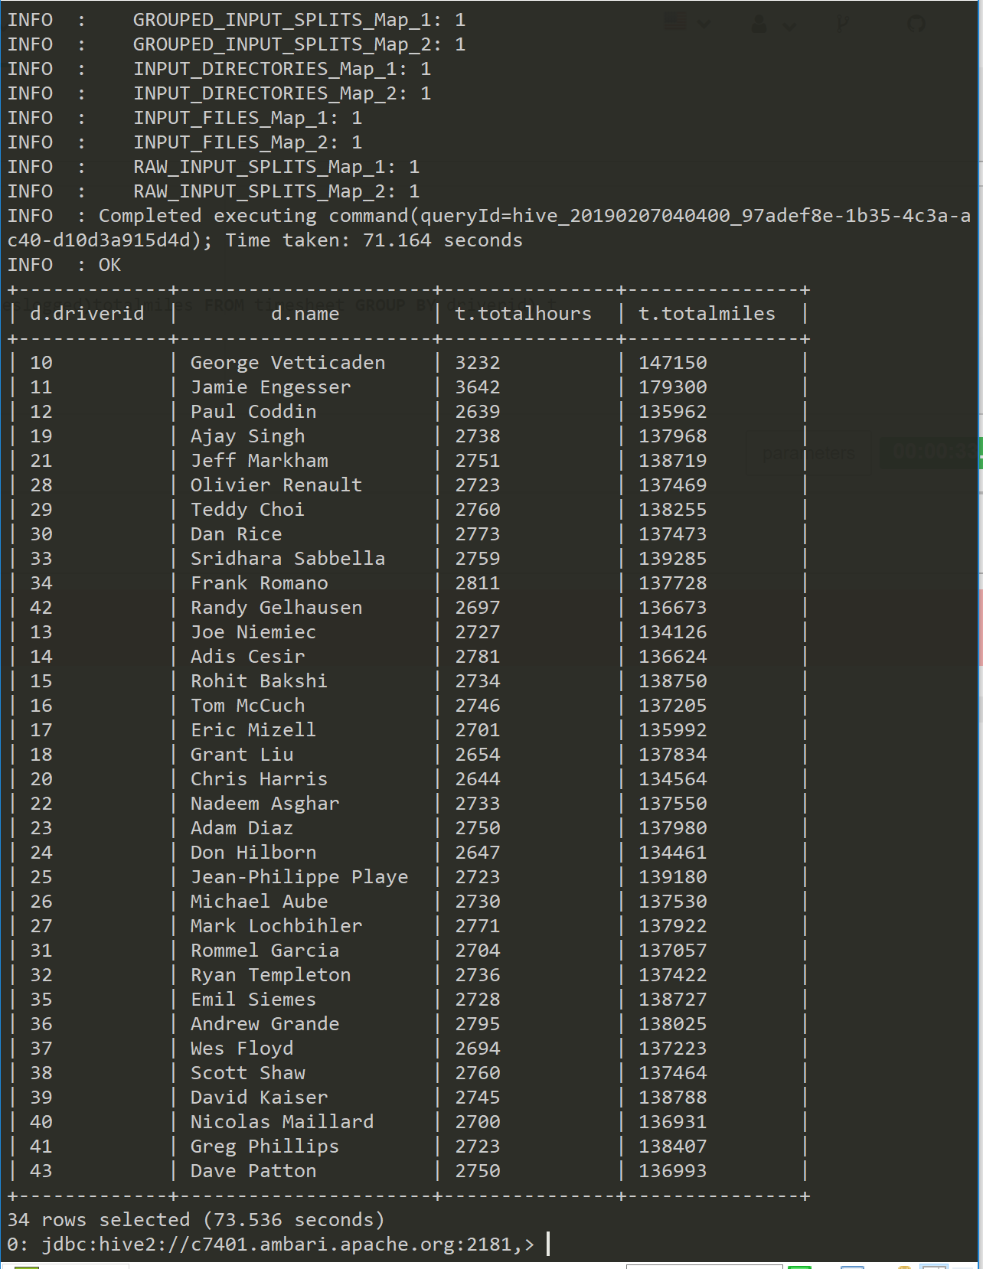

**Once again using Cmder, I was able run the query and get an output for it. Later I will go over all the steps it takes to get this to run through your Cmder prompt.**

**The result desired was the driver id, the name total hours and total miles all queried together after joining the two tables together by joining based on the driver id and combining fields from each table.**

## 1.9 Suspend Cluster

Enter the command: vagrant suspend

**After learning about the halt command I like to do that as well to my cluster:**

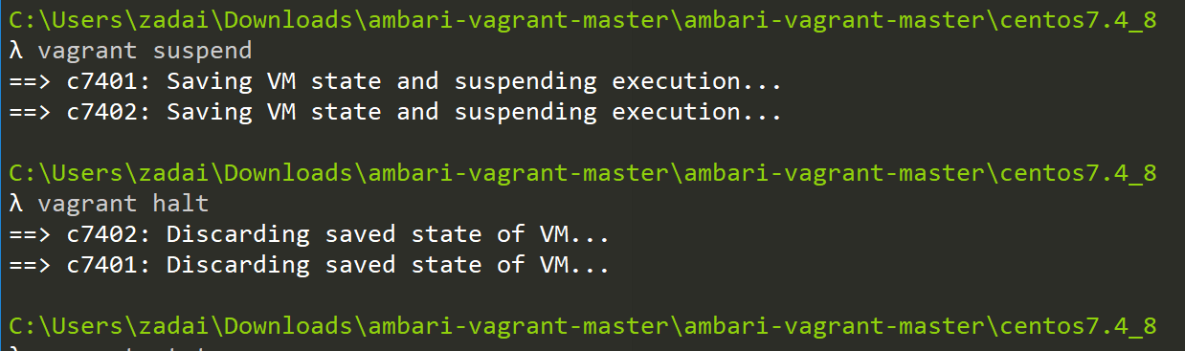

## Appendix

The process of getting around the query timeout was pivotal to me completing this lab that I had to create an appendix of the process of doing this myself. Below are the steps to go from timed out query to run query in the Cmder prompt.

1. The query has timed out in Hive.

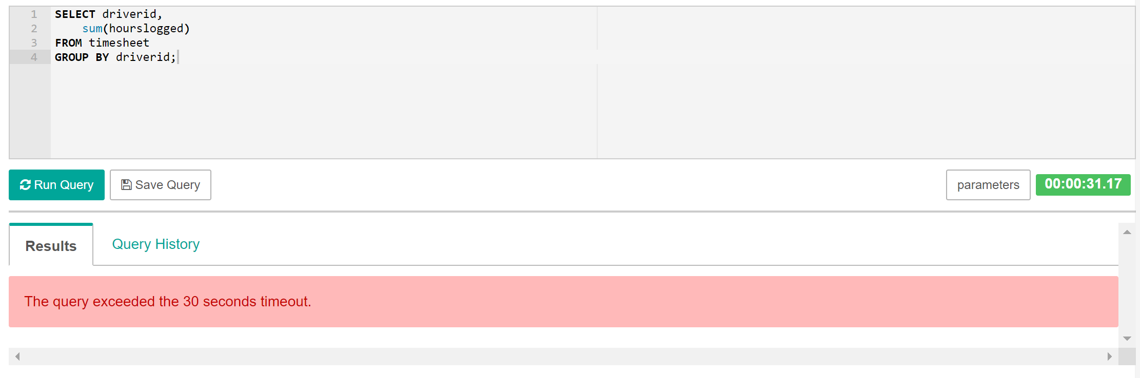

1. From here the Yarn process must be killed. For me I had to head to the URL: c7401.ambari.apach.org:8088

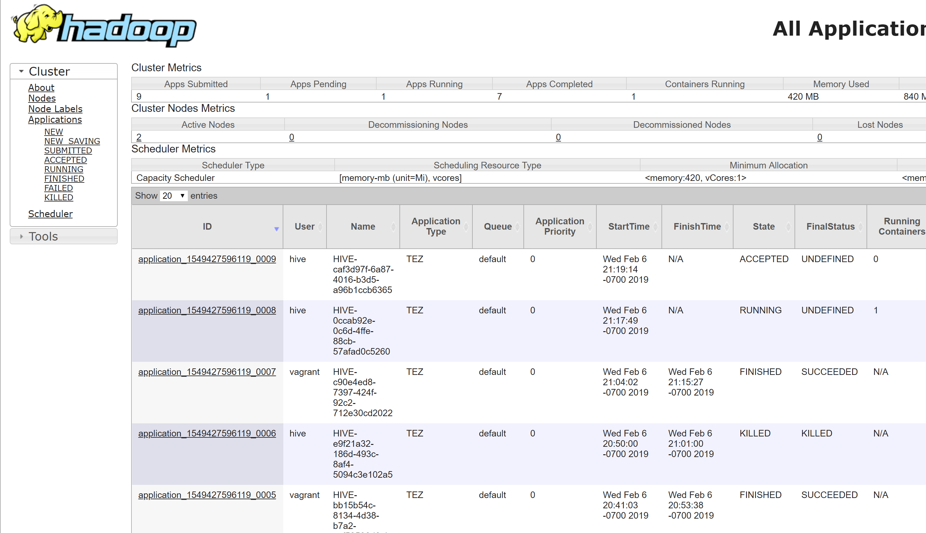

The URL will take you to the page you see above.

1. From here click on the RUNNING option on the left side of the page listed under the CLUSTER dropdown.

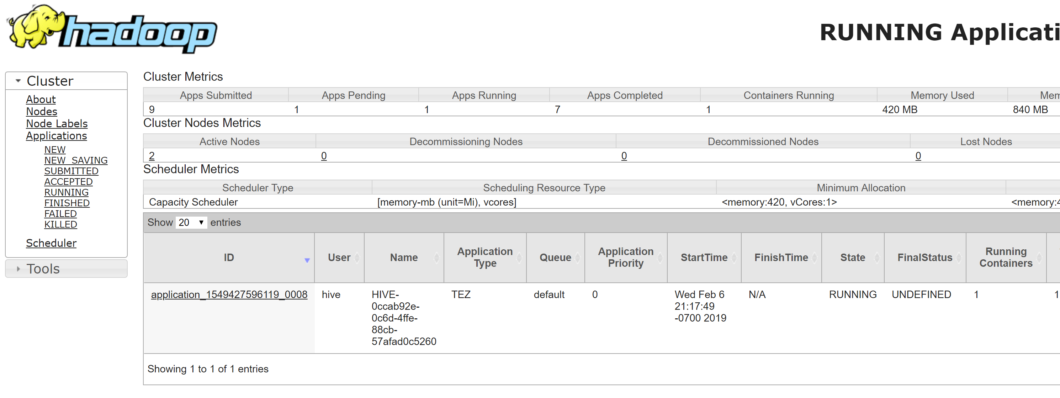

1. Copy the ID of the application that is running (include the word “application” in your copy)
2. Make sure you have Cmder open and start by going into your SSH and then to your manager settings through the root command (sudo su -)

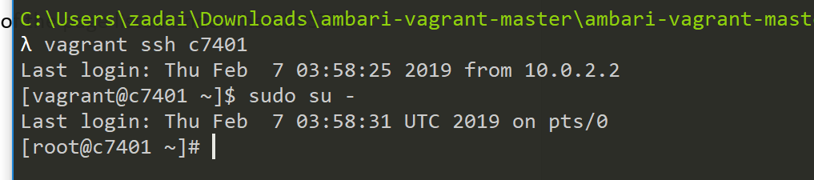

1. Use the following command followed by what you copied. Running this will kill the yarn application.

yarn application -kill [application_1549427596119_0008](http://c7401.ambari.apache.org:8088/cluster/app/application_1549427596119_0008)

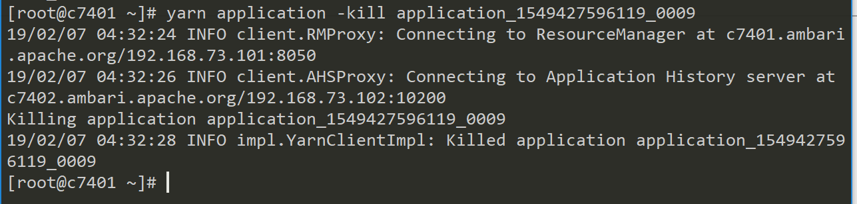

1. The application has been killed and if you go back and refresh the page the application list should be empty.

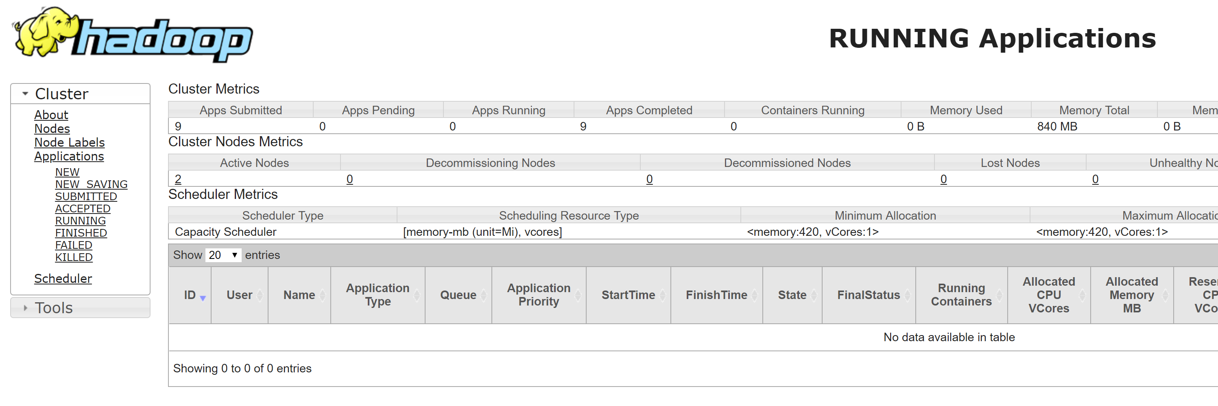

1. Now log into Hive and get out of the root manager controls before that.

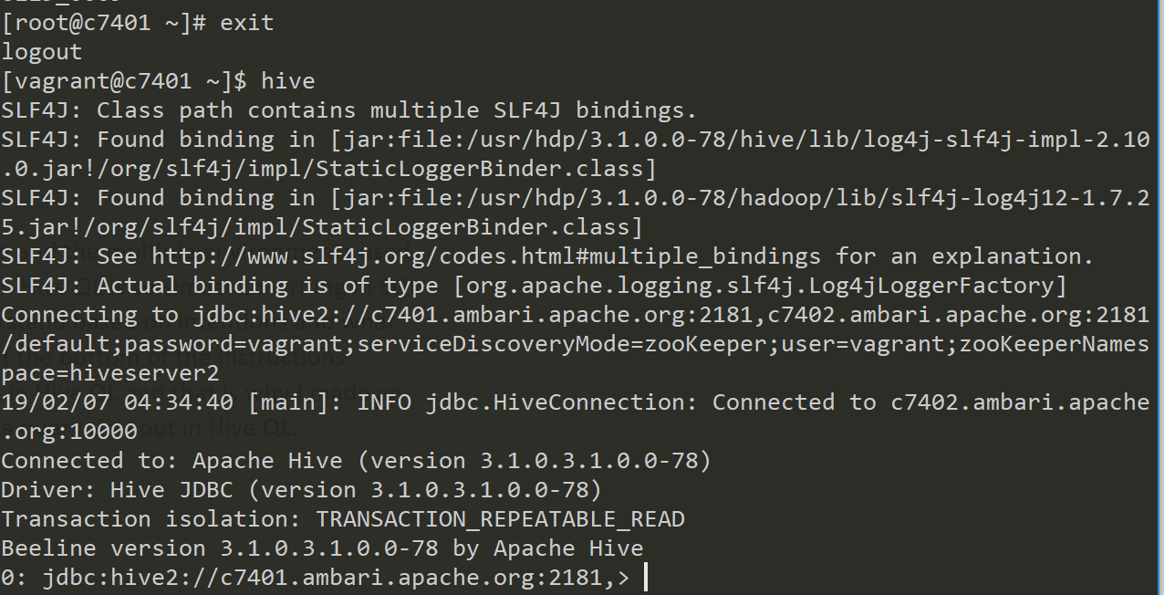

1. In Hive, write the query that was previously timing out.



1. The result below is what to expect after the query is finished running in Cmder.

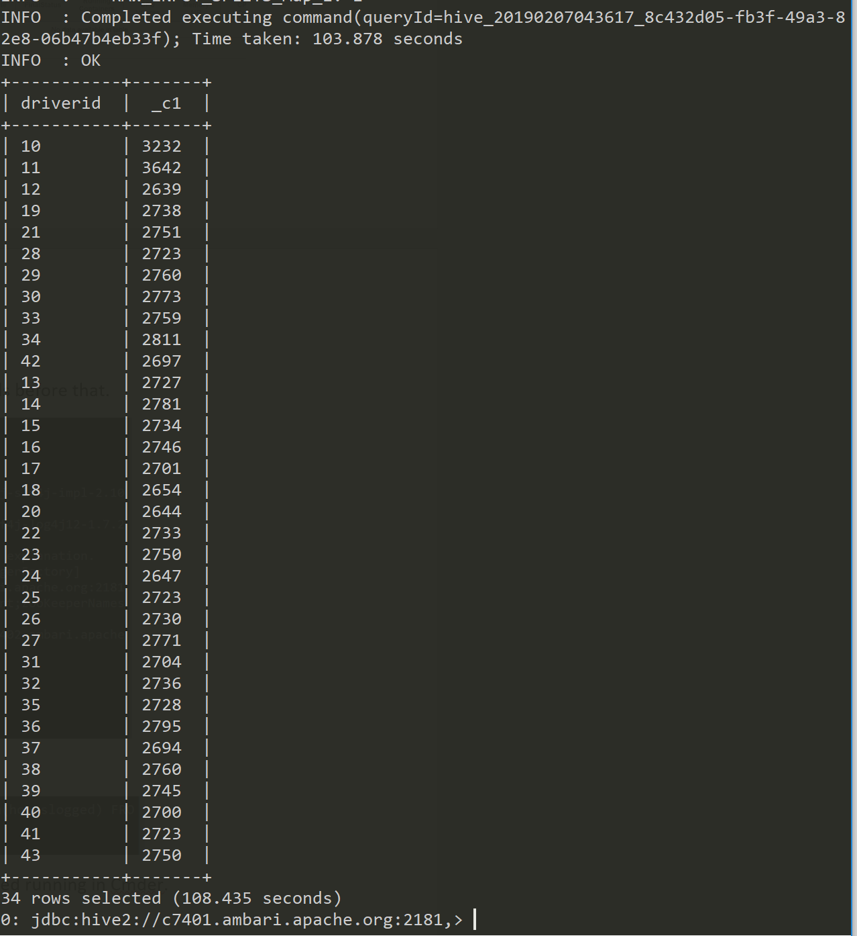

And those are the steps to go from a timed out query to a desired query result in Cmder.

## Reflection:

I found this week’s lab a fun introduction to the capabilities of Hive and the multiple environments used and the query writing in it as well. I was happy that query writing in Hive QL is so similar to writing in SQL server so the simple queries we ran for this lab were easy to understand based on intentions and what my expected output should be. I am also happy for the appendix at the bottom of the instructions because it taught me how to work around when a query times out in Hive QL and that is why I made an appendix of my own to document the steps it takes to get around a query timeout in Hive QL.